

**Synthetic Design of Artificial Intelligence System Concluding Report**

|  |  |
| --- | --- |
| Project name: | ChatSCUT |
| Project members: | 张博文，蒋新宇，俞铭一，  罗兴杰，高孟熙 |
| Supervisor: | 舒琳 |

**Ⅰ. Basic information**

|  |  |  |  |  |  |  |  |  |  |
| --- | --- | --- | --- | --- | --- | --- | --- | --- | --- |
| Project name | | ChatSCUT | | | | | | | |
| Leader | Name | 张博文 | | | | | | | |
| Student ID | 202164690634 | | | | | Class | | AI 2 |
| Grade | Junior | | Telephone | 18127986890 | | Email | | syzbw20@163.com |
| Project team members | Name | Grade | Faculty, Major | | | Telephone | | Email | |
| 蒋新宇 | Junior | Future Tech ,AI | | | 13692121857 | | 13692121857jxy@gmail.com | |
| 罗兴杰 | Junior | Future Tech ,AI | | | 18819209189 | | 1245050062@qq.com | |
| 高孟熙 | Junior | Future Tech ,AI | | | 13366702929 | | gmxgmx021203@163.com | |
| 俞铭一 | Junior | Future Tech ,AI | | | 18260083796 | | 1315715372@qq.com | |
| Relationships with other projects (SRP, etc.) | This project is an innovative idea for the group and is not dependent on any other project. | | | | | | | | |

**Directory**

1. Project background selection 6

1.1 Project background research 6

1.2 Product demand analysis 6

1.2 Product function analysis 8

1.2 Survey and study of the current situation of development at home and abroad 10

1.2.1 Market demand for campus Q&A system 10

1.2.2 Specific cases of campus Q&A system 10

1.2.3 Related products of campus Q&A system 11

1.2.4 ChatSCUT Competitive Analysis 12

2. Project objectives 17

3. Project Completion 19

3.1 ChatSCUT-Turbo 19

3.2 Multimodal file processing module 23

3.2.1 Speech-to-Text module 23

3.2.2 OCR module 24

3.2.3 PDF Module 25

3.2.4 Word processing module 26

3.2.5 Multimodal file input processing effect 27

3.2.6 Multimodal file processing demonstration 27

3.3 Metahuman module 28

3.3.1 Metahuman construction 29

3.3.2 Video Streaming 35

3.4 Multi-agent module 38

3.4.1 RAG Agents 38

3.4.2 Fine-tuning of SCUT's agents 40

3.4.3 Summarizing agents 42

3.5 Large language model module 42

3.5.2 Base model 42

3.5.3 Model fine-tuning 43

3.5.1 Retrieval Enhancement Generation 44

3.5.4 Multi-level abstract search 48

3.6 Dataset module 51

3.6.1 Data Collection 51

3.6.2 Generate summary of SCUT' documents 55

3.6.3 Fine-tune the construction of the dataset required for the model 57

3.6.4 Construction of news dataset on the official website of SCUT 59

3.7 Vector database module 60

3.7.1 Vector database construction 60

3.7.2 Dynamically update the vector database 61

3.8 Front-end module 63

3.8.1 Overall Architecture 64

3.8.2 Login Module 66

3.8.3 Chat List Module 67

3.8.4 Message input module 69

3.8.5 Message display module 71

3.8.6 Metahuman display module 72

3.9 Back-end module 73

3.10 LLM Model Evaluation 76

3.10.1 Evaluate the dataset 76

3.10.2 Response Time Assessment 78

3.10.3 Value Alignment Assessment 79

3.11 Product Design 80

3.11.1 Logo theme color scheme and shape 80

3.11.2 Interface Design 82

3.11.3 Interactive logic design 85

3.12 Summary of Results 86

3.12.1 Multimodal inputs 86

3.12.2 Return the file as a link 88

3.12.3 Multi-round conversation management and contextual understanding 88

3.12.4 Ability to comprehend complex and multi-level problems and integrate information 90

4. Summary of project innovation and advantages 91

4.1 Application innovation 91

4.2 Integrated innovation 93

4.3 Improvement innovation 95

4.4 Original innovation 100

5. The actual division of labor between project personnel 102

6.The percentage of their respective contributions 104

7. Problems with the project 104

8. Use of funds 105

9. Market prospect and post-promotion plan 105

9.1 Market Prospects 105

9.2 Post-promotion plan 106

**II. Closure for the project**

# 1. Project background selection

## 1.1 Project background research

In the current college campus environment, parents, students, and faculty are often challenged to process large amounts of information, both in the short and long term. This information includes, but is not limited to, course announcements, academic lectures, campus events, administrative affairs, and employment information. There are various channels for information dissemination, such as the school's official website, WeChat official account, education management system, enterprise WeChat message, and various social media groups. However, this scattered and diverse way of disseminating information often makes it difficult for parents, teachers and students to obtain, screen and pay attention to important information in a timely and effective manner.

## 1.2 Product demand analysis

In order to gain an in-depth understanding of the situation and opinions of parents, teachers and students of South China University of Technology on information access channels, the project team sent a questionnaire to parents, students, faculty and staff on the daily information access channels of the International Campus, and collected the following survey results:

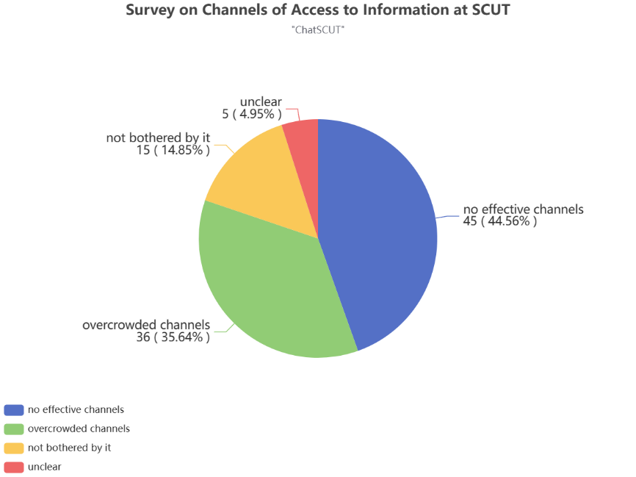

Figure 1-2-1 Survey of parents, teachers and students at South China University of Technology

According to the chart, about 45% of respondents believe that they do not have effective access to campus information. In addition, about 36% of the respondents believe that their access to information about the campus is too complicated to effectively filter and focus on information related to their needs. Worryingly, only about 15 percent of those surveyed said they were not bothered by access to information on campus.

The following chart illustrates the results of the survey respondents' needs for an intelligent Q&A system on campus:

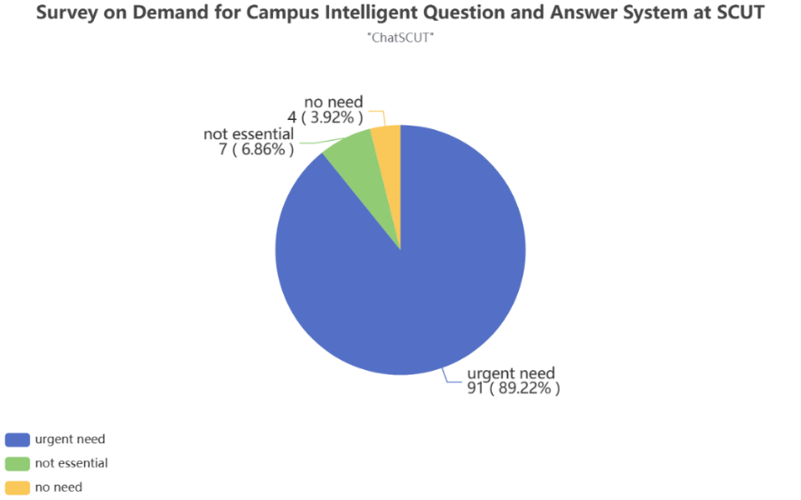

Figure 1-2-2 Survey on the demand for an intelligent Q&A system on campus

According to the chart, about 89% of the respondents agreed that there is an urgent need for an intelligent Q&A system on campus to solve the problems they face in information acquisition and processing.

Based on the above survey results, it can be seen that most parents, teachers and students of South China University of Technology are faced with the problem of being unable to obtain, screen and pay attention to important information in a timely and effective manner. This not only brings a lot of trouble, but also affects their learning and productivity, and even their quality of life. Therefore, it has become a top priority to develop an intelligent Q&A system for campus to solve this problem. The ChatSCUT project came into being, aiming to provide efficient and intelligent information management and integration services to meet the needs of teachers, students and parents for information acquisition and processing, so as to save users' query time and promote the convenience and improvement of campus learning and life.

## 1.2 Product function analysis

In order to gain an in-depth understanding of users' needs for product functions and effectively solve the core problems of the product, the project team sent a questionnaire on product function requirements to students from the International Campus, and obtained the following survey results:

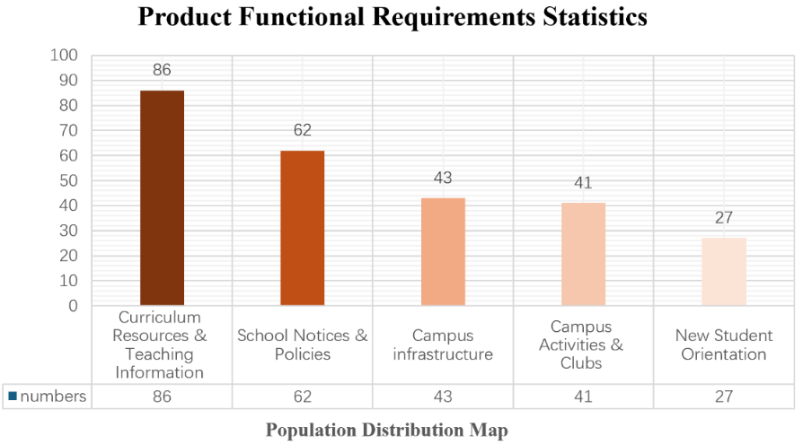

Figure 1-2-3 Statistics on product function requirements

According to the chart and the in-depth analysis of the problems and needs that students and parents may encounter in campus life, we can roughly summarize the user's needs for this product into the following aspects: (1) Admission Guide for New Students: New students may not be familiar with campus life and learning environment, so they need a comprehensive admission guide, covering guidance and suggestions on admission procedures, dormitory arrangements, course selection, etc. (2) Campus facilities information: Students and parents may be interested in information about various campus facilities, including but not limited to libraries, restaurants, sports facilities, transportation, etc., and need to know their location, opening hours, and various services provided. (3) Curriculum and teaching information: Students need to obtain information such as curriculum schedules, teaching plans, teaching materials, and even learning suggestions in order to better plan their learning time and resources. (4) Campus activities and club information: Students want to know about the various activities, competitions and clubs held on campus, and want to get relevant information in order to participate in them. (5) School notices and policies: Teachers, students and parents are very concerned about the various notices and policies issued by the school, such as changing majors, various subsidies, etc., which need to be explained in detail and resolved.

With the continuous evolution of cutting-edge technologies such as deep learning, large language models (such as GPT-3.5) and vector databases (such as Milvus) have made significant progress in the fields of natural language processing and information retrieval. The development of these technologies has enabled machines to understand natural language more accurately and provide users with a personalized interactive experience.

The ChatSCUT project will make full use of these advanced artificial intelligence technologies and collect a large amount of relevant data to achieve intelligent understanding, rapid response and accurate delivery of campus information to improve the user experience. With the help of artificial intelligence technology, it helps parents, students, faculty and staff to extract key content quickly, accurately and efficiently from the huge information flow, and provides them with centralized, concise and convenient access to information.

## 1.2 Survey and study of the current situation of development at home and abroad

### 1.2.1 Market demand for campus Q&A system

With the deepening of digital and intelligent transformation, more and more colleges and universities have begun to explore how to use AI technology to improve teaching and management efficiency, among which the campus Q&A system is especially favored by colleges and universities because it can effectively reduce the daily work burden of faculty and staff and improve the convenience of students' information acquisition.

In China, the number of higher education institutions is huge, according to the Ministry of Education, there are 2,638 ordinary colleges and universities in Chinese mainland. These schools are all potential users of the Q&A system on campus. If each university invests at least 500,000 yuan in the question and answer system every year, the potential market size will reach 1.3 billion yuan. This data shows that the campus Q&A system has great market potential in China's higher education field, especially in promoting campus digital services and improving the convenience of teachers and students, and the demand and application prospects of the campus Q&A system are expanding rapidly.

### 1.2.2 Specific cases of campus Q&A system

Peking University has developed a multi-layer strategy-based intelligent Q&A system for information services of Peking University, which uses traditional machine learning algorithms to convert query questions into preset service interfaces and search them in the database. At present, the system is integrated into the school's official WeChat service account, which can automatically answer students' queries about courses, libraries, campus activities, etc.

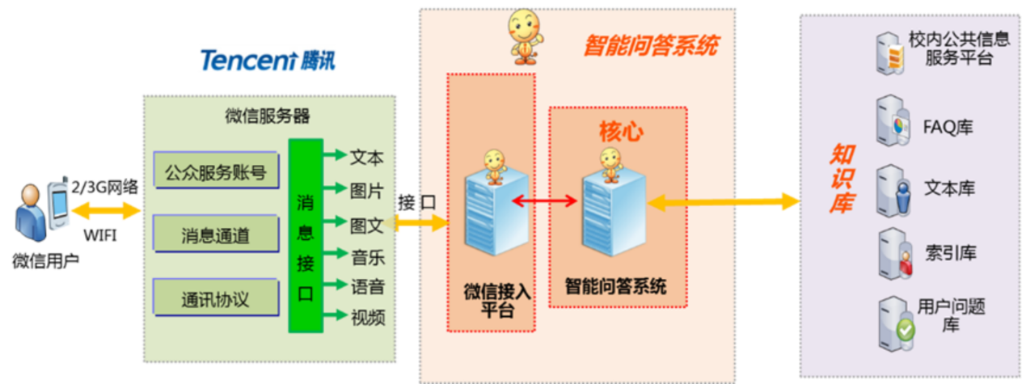

Figure 1-2-2-1 Intelligent Q&A system of Peking University Information Service

Fudan University has used its own AI research results to establish a campus Q&A system called Fu Xiaoxin integrated into the online office hall of Fudan University, which not only serves daily student Q&A, but also provides administrative service guides, and has become an important information support tool for students and faculty members.

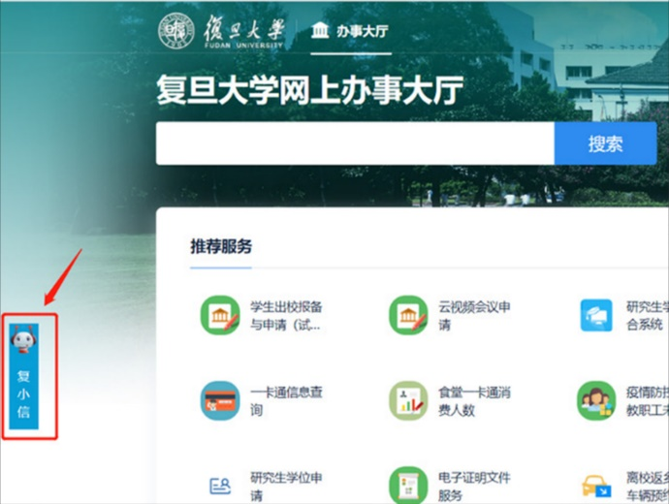

Figure 1-2-2-2 Fudan University Fuxiaoxin Campus Q&A System

### 1.2.3 Related products of campus Q&A system

At present, colleges and universities across the country are developing their own campus Q&A systems, and focusing on South China University of Technology, we know that the existing campus Q&A system has two products: SCUT Undergraduate Admissions Consulting Platform and Huaxiaowang. A detailed comparison will be made in the subsequent competitor analysis.

Although the direct market for campus Q&A systems is primarily focused on the education sector, we can also gain some market insights from companies that offer custom vertical models. These companies, such as Mobvoi or Private LLM, often offer customized solutions to meet the needs of specific industries. While these solutions are technologically advanced, they can be limited by higher costs and complex implementations when deployed in the real world. By using more targeted datasets, our campus Q&A system can have advantages in cost control and implementation complexity, which is more in line with the characteristics and needs of the education industry, and has stronger competitiveness.

### 1.2.4 ChatSCUT Competitive Analysis

**(1) Hua Xiaowang, South China University of Technology**

Aimed at the student users of South China University of Technology, the Huaxiaowang Mini Program integrates many functions to meet the various needs of students in campus life, including intelligent customer service functions. The intelligent customer service realizes the consultation function including daily school affairs, weather, news, movies and music, etc. The project was completed in 2020 and is a question-and-answer system based on information retrieval.

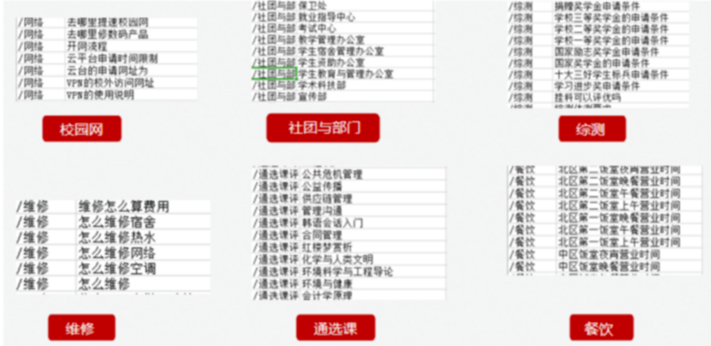

Figure 1-2-4-1 Partial corpus of Hua Xiaowang

Different from ordinary information retrieval technology, our project uses a large language model implementation, which has many advantages over information retrieval-based systems, as follows:

**1. Ability to understand complex problems and integrate information**

Large language models are capable of understanding complex queries and natural language expressions, including implicit intent and context. This means that no matter how specific or complex a question is asked by a student, teacher, or staff, AI can effectively parse and give appropriate answers. Large language models can extract and integrate information from multiple data sources, rather than just returning information from a single data source.

Information retrieval systems often rely on keyword matching technology, and if the keywords do not appear directly in the database or the user expression is ambiguous, the system may find it difficult to understand and respond correctly. At the same time, the information retrieval system also lacks the ability to integrate data sources, making it difficult to provide cross-domain answers.

**Scenario example: Students' multiple questions about career planning**

Question: "I'm a business school student and I'm about to graduate." I'm interested in both marketing and data analytics and am not sure which field of career I should pursue, or is there a way to combine the two fields of work? ”

**Responses from large language models:**

**Understanding and synthesis:** Large language models are able to understand the uncertainty of career interest and the exploration of multidisciplinary integration contained in this problem. It might provide an answer like, "It's a good advantage that you're interested in both marketing and data analytics." With data-driven marketing strategies gaining traction these days, you might consider looking for a position that combines both areas, such as a market analyst or digital marketing specialist. These roles often require the use of data analytics skills to optimize marketing strategies and improve business outcomes. Additionally, taking some short courses or certifications on data science and marketing will help you stand out in your job search. ”

**Response of the information retrieval system:**

**Keyword matching and information returns:** Information retrieval systems may return career information related to "marketing" and "data analytics" separately, but often lack specific recommendations for combining the two. The system may not be able to understand the complexities of a user's interest in two fields at the same time, and it may be difficult to provide recommendations on how to integrate career paths in both fields.

**2. Contextual understanding and multi-round conversation management**

The ability of large language models to sustain and manage long conversational contexts is important for solving complex consultations that require multi-step explanations or multiple related issues. However, the information retrieval system lacks the understanding of the content of the dialogue before and after, and it is difficult to maintain coherence in complex interactions.

**Scenario example: A continuous conversation between a student about enrolling in a course**

**Question**: "I'm a freshman and I want to know how to sign up for elective or general education courses next semester." ”

- **Large language model** responses:

- **First round of answers**: "Welcome! Course selection is usually made through the school's student information system. You need to log in to the system first, and then you can choose the course you are interested in. Need me to explain how to do it for you? ”

- Student: "Yes, please tell me the steps." ”

- **Second round of answers**: "Of course, first make sure you've received your login credentials. Once logged in, navigate to the 'Course Registration' section. You can view the list of available courses, select the courses you want, and add them to your class schedule. Finally, confirm your choice and submit. During registration, you can always contact the Registrar's Office or Student Support Services if you encounter system issues or questions. ”

- **Student**: "How do I contact the Registrar's Office?" “

- **Third round of answers**: ......

- **Response of the information retrieval system**:

- **Round 1 response**: "Click here to view the course registration guide." (Provide a generic answer that links to the school's registration page).

- **The student answers**, "I don't know how to choose a course. ”

- **Second round of responses**: The information retrieval system may only provide the same or similar links repeatedly, or may not understand the context and cannot directly explain the specific steps of "selecting a course".

**3. Better personalization and adaptability**

The large language model can be adjusted according to the language style and behavior patterns of different users, making communication more natural and friendly. This adaptability also includes the ability to integrate language and response strategies based on different business needs. This is essential to build trust and satisfaction with AI systems among students and staff.

**Scenario example: Learning consultation for different students**

**Question 1** (from a more anxious student): "What should I do if I feel completely unprepared for the upcoming chemistry exam?" ”

**Question 2** (from a lighter student): "Hey, what should I review for the chemistry exam?" Are there any tips? ”

- **Large language model** responses:

- **Response to anxious students**: "I understand your concern, pre-exam nervousness is common. You can try to break the review into small sections and review them step by step. I suggest you start with past exams and class notes, paying special attention to the parts that the teacher emphasized. Also, try doing some relaxing activities, such as deep breathing or short walks, which can help improve your study efficiency. ”

- **Response to relaxed students**: "Hey, it's great to see you so relaxed about exams!" A tip is to focus on revising concepts that have been emphasized by the teacher in class, as well as questions that have often arisen in past exams. Also, doing some practice questions is a great way to strengthen your understanding. Good luck with your exams! ”

- **Response of the information retrieval system**:

- **General response**: You might provide a standardized response, such as: "To review the chemistry exam, you can review key passages in the textbook and do some practice questions." This response may be the same for all students and does not reflect the adaptability of individual emotional states or tones.

**4. Reduce reliance on preset rules and provide a more natural conversational experience**

Large language models are able to understand user input well and support the generation of coherent and natural responses, making conversations more fluid and human. Communicating with such a system feels more like a user talking to a real person than with a machine based on strict rules.

**5. Better error handling**

Large language models are generally better at handling ambiguity in language and errors in user input, and are able to better understand intent, even if the input has spelling or grammatical errors.

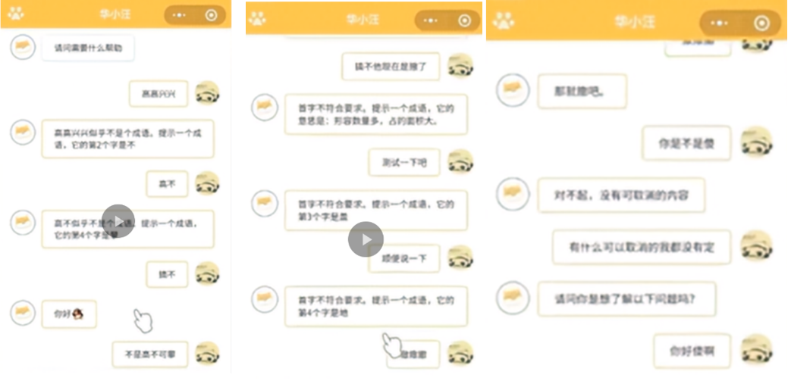

Figure 1-2-4-2 Hua Xiaowang use case

From the above use cases of Hua Xiaowang, we can find that Hua Xiaowang's comprehension ability is very limited, and the answers are highly dependent on preset rules, and when the user's input does not meet his expectations, he cannot correctly understand the user's semantics and cannot guide the user to ask further questions. At the same time, its ability to understand and manage the context is also very limited, and when the user changes the topic halfway, Hua Xiaowang is still entangled in the previous topic, unable to correctly understand the user's semantics and change the topic accordingly.

(2) Undergraduate Admissions Consultation Platform for Chinese University of Technology

The SCUT Undergraduate Admissions Consultation Platform is an intelligent Q&A system on the official website of SCUT, which can answer a series of questions related to our school. The platform is similar to Hua Xiaowang in that it is also based on an information retrieval system. Since the advantages of large language models over information retrieval systems in the implementation of AI question answering systems have been described in detail in Hua Xiaowang's analysis, they will not be repeated here. In addition, the platform has the problem of too few datasets and poor semantic matching effect, as shown in the figure below, and after testing, it was found that the platform could not answer many questions, with low intelligence and high limitations.

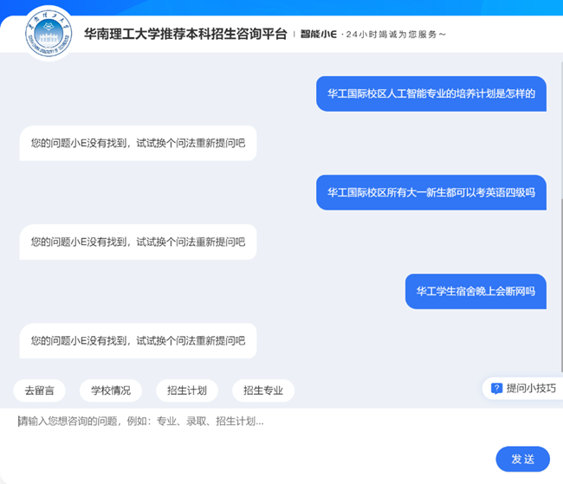

Figure 1-2-4-3 The use case of the Undergraduate Enrollment Information Platform recommended by SCUT

# 2. Project objectives

The core goal of the project is to establish and implement an intelligent question and answer system, which aims to solve various problems encountered by students and parents of South China University of Technology (SCUT) in campus life, help users quickly obtain targeted solutions, and enhance their experience and satisfaction in campus life. Specifically, project objectives include, but are not limited to:

1. Provide an intelligent question and answer system covering various questions that students and parents of South China University of Technology may encounter in campus life, including study guidance, admission procedures, dormitory arrangements, course selection, campus facilities and activity information, etc.

2. Through the establishment of a vector database of school information and fine-tuning of large language models, efficient Q&A functions are realized to ensure that the system can understand users' queries and provide accurate and comprehensive answers, as well as personalized solutions.

3. Design a user-friendly interface that is easy to interact with the system. We've added a metahuman to the front-end page, and the responses of the large language model can be spoken by the metahuman. At the same time, the shape and voice of the metahuman are also customizable.

4. Continuously improve and optimize the system according to user feedback and needs, and continuously improve its functions and performance to ensure that it can continue to meet the actual needs of users and maintain a leading position.

In conclusion, the core goal of the project is to establish an intelligent question and answer system to provide comprehensive and personalized information services for students and parents of South China University of Technology, and solve various problems and queries encountered in campus life, so as to improve the convenience and comfort of campus life.

# ****3. Project Completion****

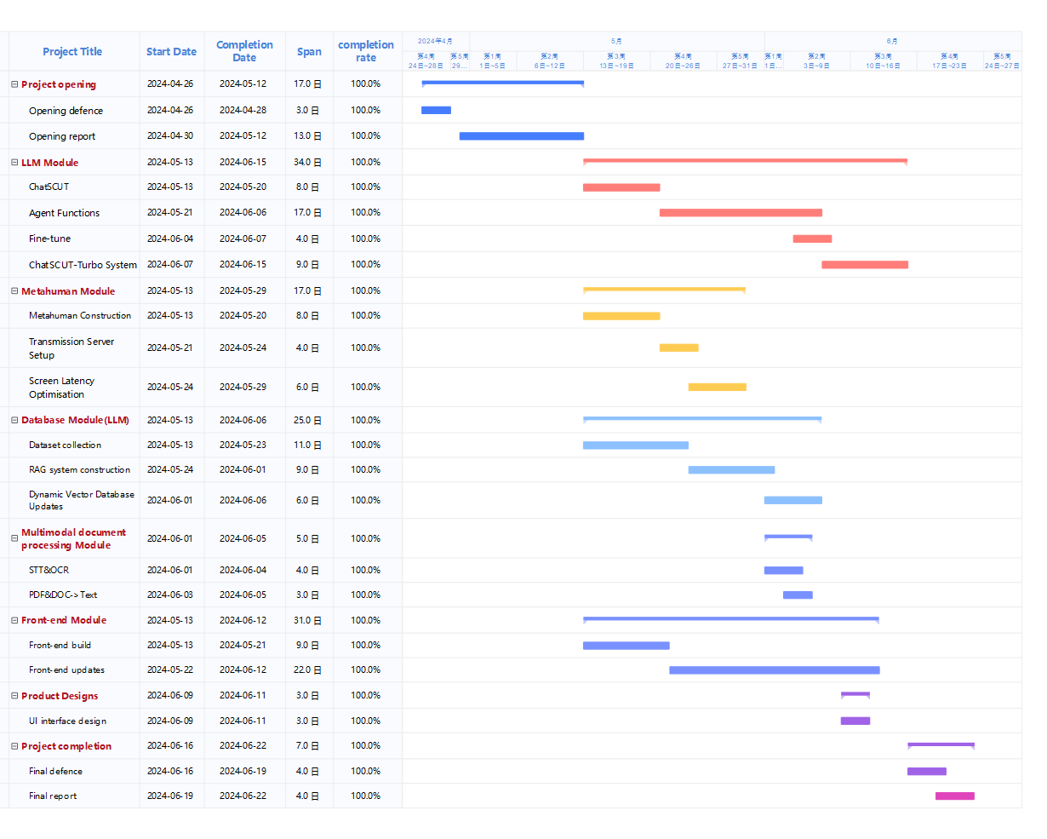

Figure 3-1 Gantt chart of project progress

## 3.1 ChatSCUT-Turbo

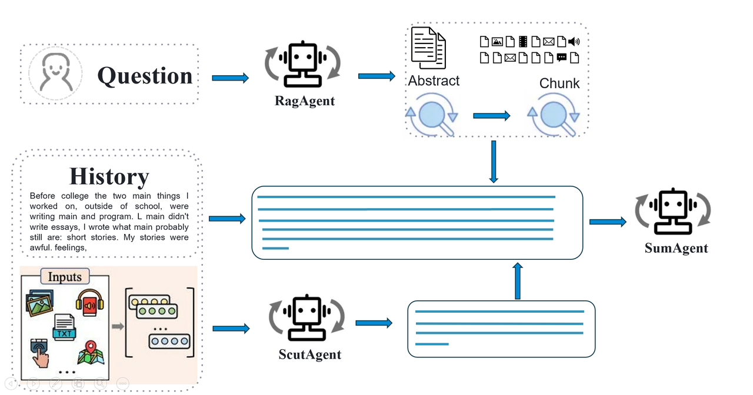

Figure 3-1-1 ChatSCUT-Turbo system architecture

In order to enhance our conversational capabilities, the ChatSCUT-Turbo system introduces a multi-agent architecture.

(1) The overall architecture and workflow of the system:

1. Question: The question entered by the user will first be processed by the RAG Agent.

2. RAG Agent Judgment: The RAG Agent decides whether a search is required and obtains relevant information from the Abstract and Chunk components.

3. History and Inputs: The user's history and multimodal inputs are sent to the ScutAgent for processing.

4. ScutAgent processing: ScutAgent combines user history and multi-modal input for in-depth understanding and generation.

5. Summary Agent：Eventually, all the information is passed to the Summary Agent to generate the final answer.

6. System output: The system returns an accurate answer to the user that has been processed and summarized multiple times.

(2) The following is the detailed workflow of the system and the functional description of each component:

1. User input questions: When a user enters a question, the system first goes through the RAG Agent (Retrieval Enhancement Generating Agent).

2. Judgment by the RAG Agent: The RAG Agent is responsible for determining whether it is necessary to use RAG technology to retrieve relevant information. If required, the RAG Agent retrieves the relevant information from the relevant document or dataset.

3. Branch processing: The other branch sends the user's historical conversation history and multimodal input (including files of various formats and even audio) to the ScutAgent for processing.

4. ScutAgent processing: ScutAgent is a large language model (LLM) that has been fine-tuned by data from South China University of Technology. It combines the user's historical conversations with multimodal input for in-depth understanding and processing to provide more accurate answers.

5. Information summary: The information retrieved by the RAG Agent and processed by the ScutAgent will be summarized into four main contents. These four paragraphs are sent to the Summary Agent for final summary and processing.

6. Summary Agent: The Summary Agent is responsible for summarizing the information processed above, generating the final answer, and returning it to the user.

Since the performance of the ChatSCUT-Turbo system is significantly improved compared to the previous generation of ChatSCUT, we call this overall system ChatSCUT Turbo.

(3) System advantages

1. Multi-agent architecture: The RAG Agent, ScutAgent, and Summary Agent work together to achieve efficient integration of information retrieval, processing, and summarization.

2. Multi-modal input: It supports processing input files in various formats, including text and audio, etc., which enhances the flexibility and adaptability of the system.

3. High performance: Compared with the previous generation system, ChatSCUT Turbo has significantly improved processing speed and answer accuracy, and can respond to users' questions faster and more accurately.

Here are other examples:



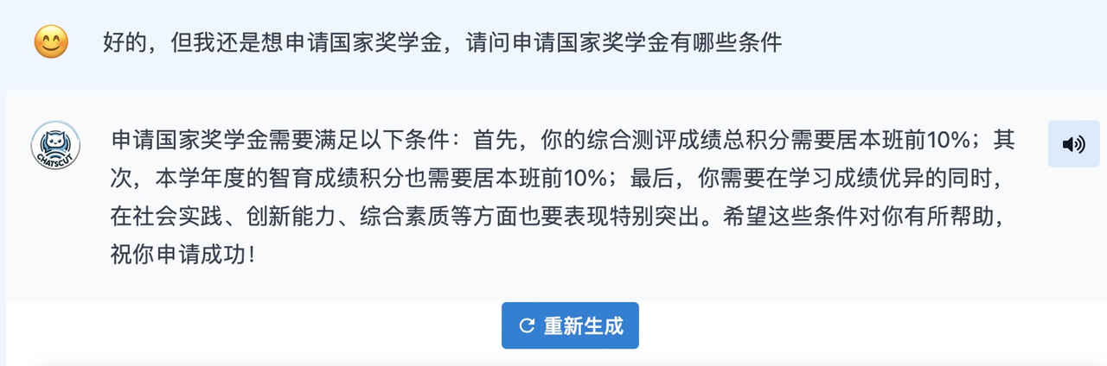

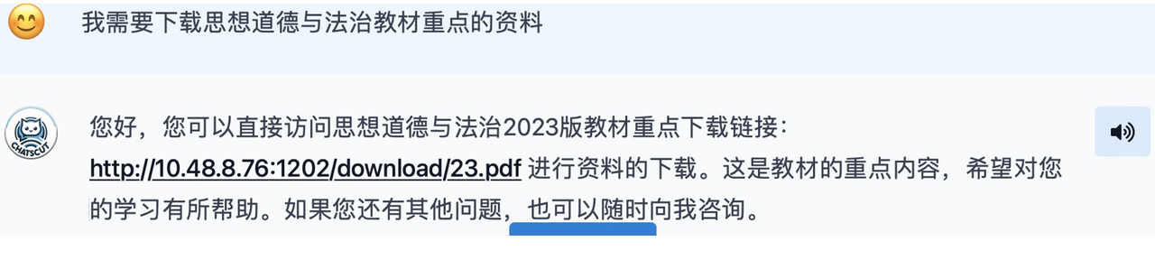



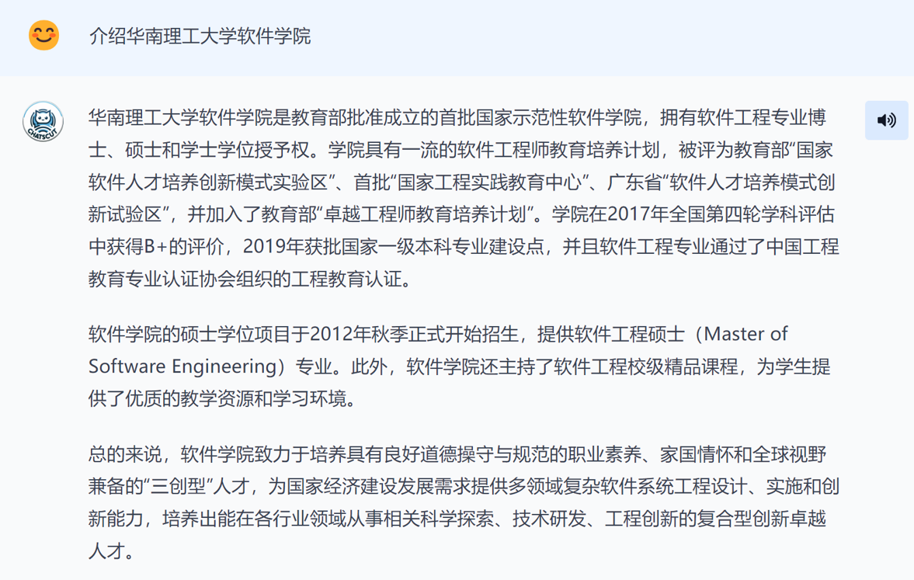

## 3.2 Multimodal file processing module

Overview: This module will support large models to work with a variety of file formats, including images, speech, PDF, DOC, etc. When users submit prompts, they can upload these documents to more fully express their needs or provide references. This feature will enhance the user experience and allow users to interact with the system more flexibly, allowing the system to provide more precise and personalized responses based on different file types.

### 3.2.1 Speech-to-Text module

Module progress and completion:

The purpose of this module is to convert the user's speech into text, so we use the Whisper model. It's an automatic speech recognition model trained on 680,000 hours of multilingual data collected from the web, and it's robust to accents, background noise, and technical language. The following is the network structure of Whisper:

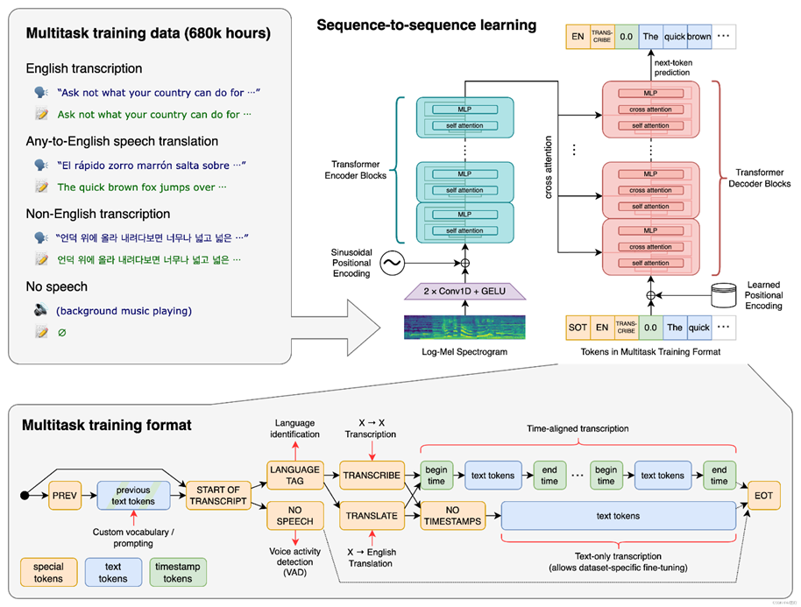

Figure 3-2-1-1 Whisper network structure

After the model is deployed, we wrap it into an interface for the front-end to call. After testing (the effect evaluation figure is shown below), it is found that the recognition accuracy of this module is as high as about 95%, which meets the user's expectations.

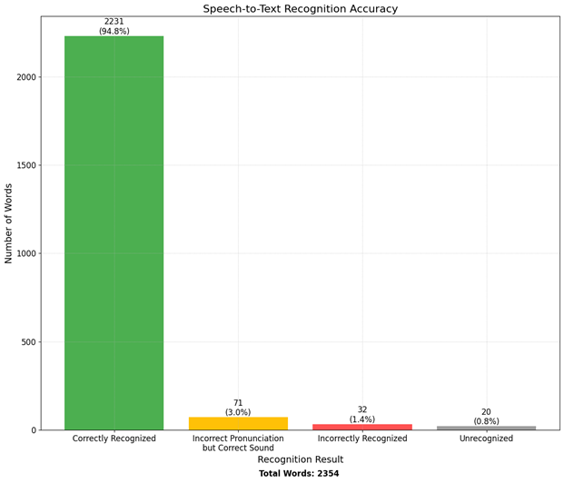

图3-2-1-2 Speech-to-Text模块效果评估图

### 3.2.2 OCR module

Module progress and completion:

The purpose of this module is to recognize and extract the text and symbols of the image file input by the user, but due to the poor effect of trying Tesseract OCR, after many attempts, we adopted the Tencent Cloud Universal Print Recognition (High Definition Version) service.

The model supports the recognition of whole image text in multiple scenes and different layouts. In addition to Chinese and English, it also supports Japanese, Korean, Spanish, French, German, Portuguese, Vietnamese, Malay, Russian, Italian, Dutch, Swedish, Finnish, Danish, Norwegian, Hungarian, Thai, and other languages

After the model is deployed, we also encapsulate it as an interface for the front-end to call. After testing (the effect evaluation figure is shown below), it is found that the recognition accuracy of this module is as high as 95.3% in pure Chinese, 96.6% in pure English, and the recognition accuracy can still reach 93.25 in the case of mixed Chinese and English, which meets the user's expectations.

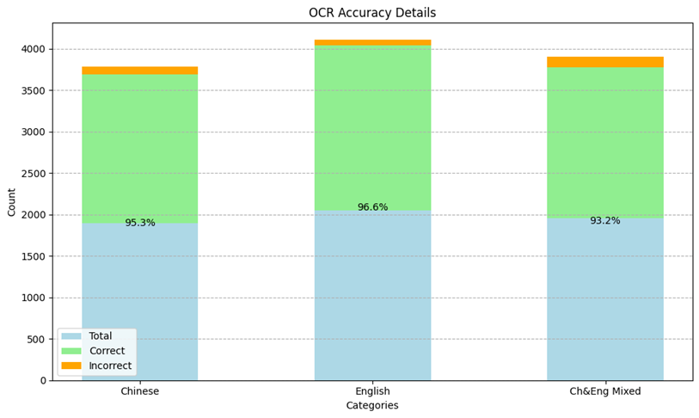

Figure 3-2-2-1 Evaluation of the OCR module

### 3.2.3 PDF Module

To extract text from PDF documents, we used the PyMuPDF library. PyMuPDF is a lightweight PDF and XPS document processing library that provides a simple and efficient way to access and manipulate the content of PDF files.

（1）fitz.open

How it works: The fitz.open method is used to open a PDF document. It allows you to read the contents of a file by file path or stream. In this project, we used a stream to read the uploaded PDF file.

Implementation details: Call fitz.open(stream=file.read(), filetype="pdf"), where file.read() reads the content of the uploaded PDF file, and filetype="pdf" specifies the file type as PDF. This method returns a PDF document object, allowing for further manipulation.

（2）pdf_document.load_page

Principle: The pdf_document.load_page method is used to load a specific page in a PDF document. It takes a page index as a parameter and returns the corresponding page object.

Implementation details: Load the content of each page via pdf_document.load_page(page_num), where page_num is the index of the page (starting at 0). Loaded page objects can be used for text extraction.

(3) page.get_text

Principle: The page.get_text method is used to extract text from a PDF page. This method provides a variety of text extraction modes, including plain text, HTML, XML and other formats. In this project, we used plain text mode to extract the text content of each page.

Implementation details: Call page.get_text() to extract the plain text content from the page and add it up into the final text string. This makes it possible to extract all the text content in the PDF page by page.

### 3.2.4 Word processing module

For text extraction of Word documents, we used the python-docx library. python-docx is a library that processes Microsoft Word documents, supporting creating, modifying, and reading files in .docx formats.

（1）docx. Document

Principle: docx. The Document method is used to load a Word document. It reads and transforms the document content into an actionable document object. This object provides an interface to access various parts of the document, such as paragraphs, tables, and images.

（2）doc.paragraphs

How it works: The doc.paragraphs property returns all paragraphs in the document. Each paragraph is a self-contained object that contains the textual content of the paragraph and its formatting information.

Implementation details: By traversing each paragraph object in doc.paragraphs, you can access all the text paragraphs of the document and extract the text content within them.

(3)para.text

Principle: The para.text property is used to get the plain text content in a paragraph. Each paragraph object has a text property that contains the text of that paragraph.

Implementation details: Iterate through each paragraph object, call para.text to extract the text content in the paragraph, and add it up into the final text string. At the same time, in order to keep the line break between paragraphs, add line breaks after the extracted text content.

### ****3.2.5 Multimodal file input processing effect****

Through the combination of the above methods, we are able to efficiently extract text from speech files, image files, PDF and Word documents, and integrate them into a complete string for subsequent large language model processing. This ability to process multimodal inputs allows our model to perform well in a variety of formats, improving the usability and user experience of the system.

Our approach is not only simple to use, but also highly accurate and efficient, capable of handling complex documents with rich content. This satisfies the needs of multimodal input processing and improves the file processing capability and adaptability of large language models. It provides a solid foundation for the performance of our model in various application scenarios.

### 3.2.6 Multimodal file processing demonstration

As shown in the figure below, the large model supports users to upload files including images, voices, PDFs, and DOCs from the local area.

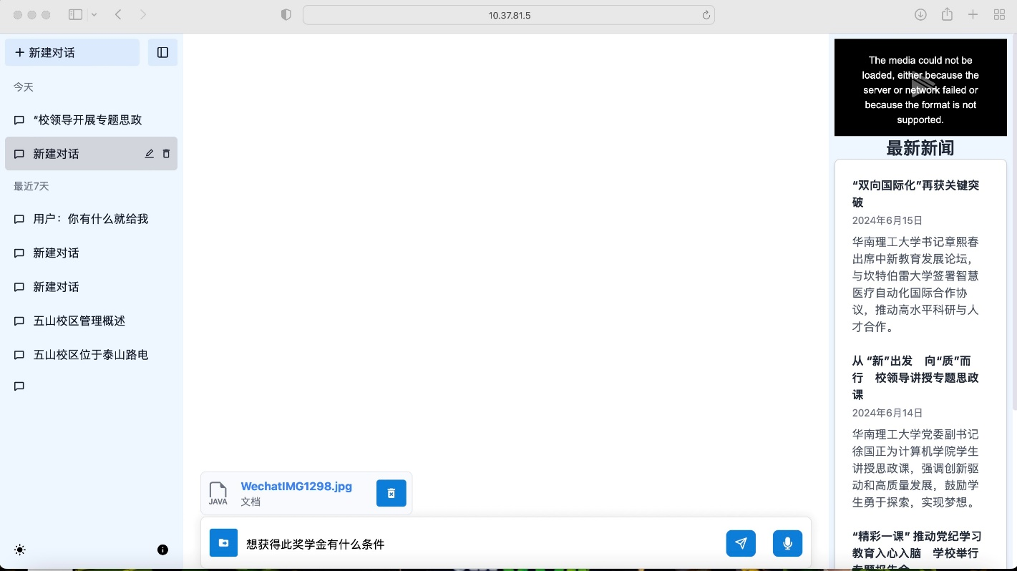

Figure 3-2-6-1 Multimodal file processing

## 3.3 Metahuman module

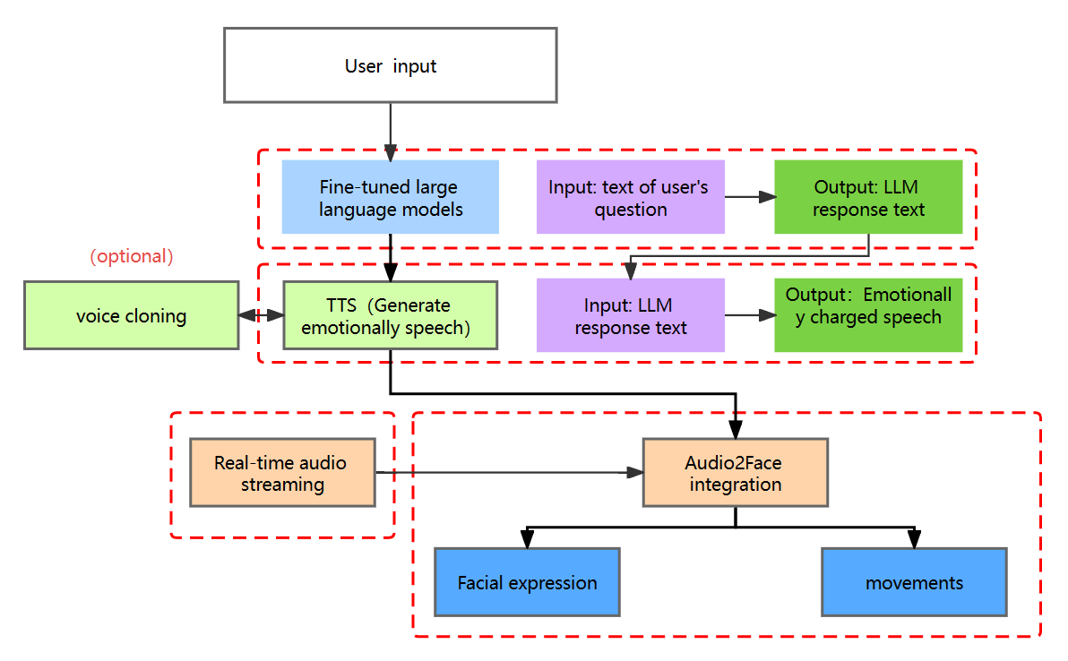

Figure 3-3-1 Structure diagram of the metahuman module

Mission Overview: Design a digital character using MetaHuman Creator, including blending facial features, refining facial expressions, styling hairstyles, adjusting body proportions and clothing, and more. To improve the realism of the digital characters, the module used UE5 and Audio2Face to drive facial expressions through audio inputs. The goal of the project is to synchronize the metahuman's facial expressions with the voice output to create a responsive and interactive interactive experience.

### 3.3.1 Metahuman construction

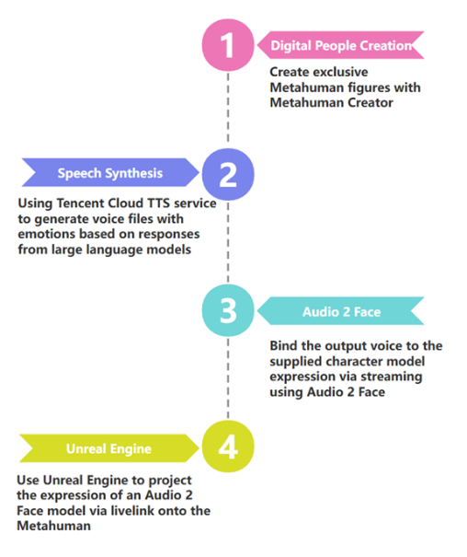

Figure 3-3-1-1 Flowchart of metahuman construction

Module progress and completion:

1. Metahuman image construction:

Because this module will be based on the Epic Platform's Unreal Engine, consider using a compatible MetaHuman Creator when building a digital avatar, as shown in the image:



Figure 3-3-1-2 Metahuman image

(2) Emotional voice file generation:

In this part, we use Tencent Cloud's speech synthesis service, which supports streaming speech synthesis (real-time speech synthesis), which can synthesize voices while delivering voices, which is suitable for scenarios with high real-time requirements such as voice robots, and this service supports the synthesis of pure Chinese, pure English, mixed Chinese and English, and Cantonese content.

We use the HTTP protocol to send a request to Tencent's server, and return an emotional voice.

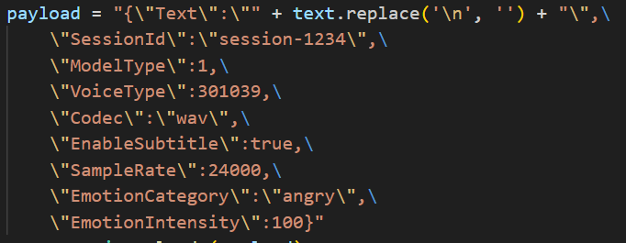

Figure 3-3-1-3 Playload configuration

(3) Configuration of Audio2Face:

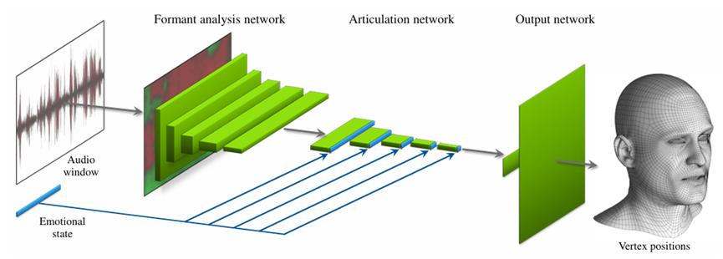

Figure 3-3-1-4 Schematic diagram of Audio2Face

This deep neural network structure consists of a dedicated layer, 10 convolutional layers, and 2 fully connected layers. The specific structure is shown in the following table:

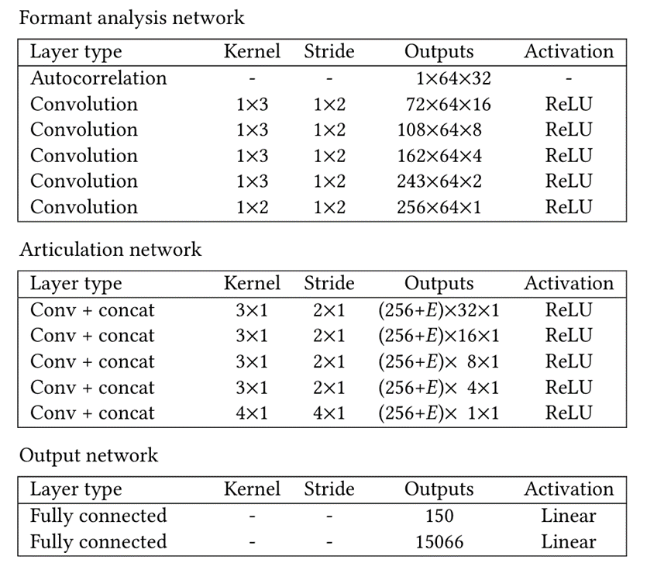

Figure 3-3-1-5 Deep neural network diagram

Specifically, there are three layers: (1) Resonance analysis network: a human speech analysis layer that is used to extract a sequence of speech features that change over time and then drive pronunciation. The information is first extracted using a fixed function autocorrelation analysis function, and then refined using five convolutional layers. Once trained, the network extracts short-term features in the human voice: phonemes, intonation, stress, and specific phonemes. (2) Articulation network: composed of five convolutional layers, the temporal evolution of features is analyzed, and the abstract feature vector describing the facial pose in the center of the audio window is finally output. This layer receives (learned) emotional states as input and eliminates incoherence between different expressions and speaking styles. The emotional state is represented as an electron-dimensional vector that we connect directly to the output of each layer in the connected network, enabling subsequent layers to change their behavior accordingly. This layer of the network outputs a set of abstract features in 256+E dimensions that together represent the desired facial pose. (3) Output Network: Generates the final 3D position of 5022 control vertices. The output network consists of a pair of fully connected layers that perform a simple linear transformation of the data.

Connect the temporal properties of the character model to the temporal properties of the Audio2Face Core instance:

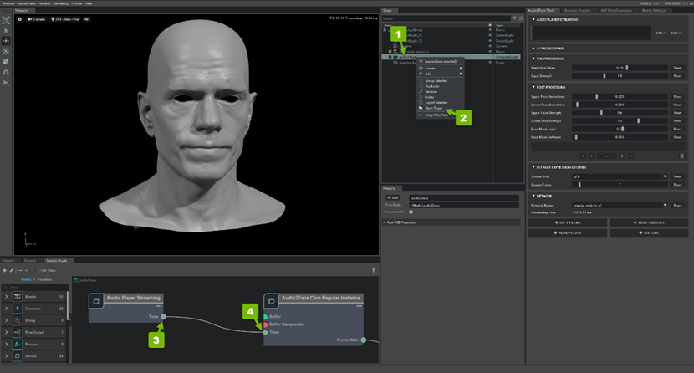

Figure 3-3-1-6 Audio2Face operation flowchart

The following is the configuration code for driving Audio2Face in real time for a voice file

def stream_audio_to_audio2face(audio_path, url, instance_name):

data, samplerate = soundfile.read(audio_path, dtype="float32")

if len(data.shape) > 1:

data = np.average(data, axis=1)

chunk_size = samplerate // 10

sleep_between_chunks = 0.001

block_until_playback_is_finished = True

with grpc.insecure_channel(url) as channel:

stub = audio2face_pb2_grpc.Audio2FaceStub(channel)

def make_generator():

start_marker = audio2face_pb2.PushAudioRequestStart(

samplerate=samplerate,

instance_name=instance_name,

block_until_playback_is_finished=block_until_playback_is_finished,

)

yield audio2face_pb2.PushAudioStreamRequest(start_marker=start_marker)

for i in range(len(data) // chunk_size + 1):

time.sleep(sleep_between_chunks)

chunk = data[i * chunk_size: i * chunk_size + chunk_size]

yield audio2face_pb2.PushAudioStreamRequest(audio_data=chunk.astype(np.float32).tobytes())

request_generator = make_generator()

print("Sending audio data...")

response = stub.PushAudioStream(request_generator)

if response.success:

print("Audio streamed to Audio2Face successfully")

else:

print(f"ERROR: {response.message}")

print("Channel closed")

(4) Stream mapping Audio2Face's character expressions onto the character model in UE5:

Install the audio2face-ue-plugins plugin in UE5, then open LiveLink and add the NVIDIA Omniverse Live Link Source; Start Audio2Face and activate the streaming link, the following diagram shows the operation flowchart.

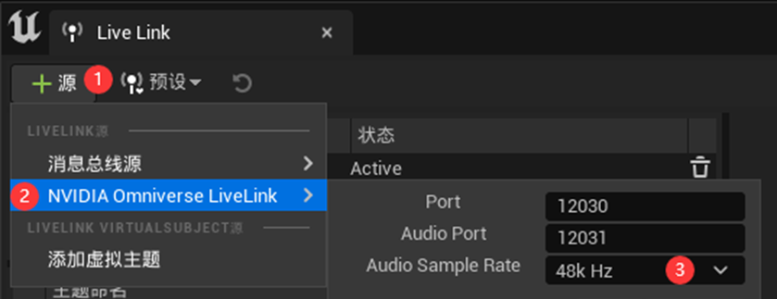

Figure 3-3-1-7 UE5 operation flowchart

(5) Connect the metahuman module with the front end:

The following is the interface function code:

@app.route("/", methods=['POST'])

def metaHuman():

if request.is_json:

text = request.get_json().get("message", "")

# Encode and decode to ignore any non-utf-8 characters

text = text.encode('utf-8', 'ignore').decode('utf-8', 'ignore')

# Remove extra spaces

segments = re.split(r'[。；] \s*', text)

# Split text by period followed by optional whitespace

segments = re.split(r'\。 \s*', text)

for segment in segments:

print("/n")

print(segment)

TEXT_FILE_PATH = 'C:\\Users\\13157\\Desktop\\AISYS\\llmresponse.txt'

AUDIO_OUTPUT_PATH = 'C:\\Users\\13157\\Desktop\\AISYS\\temp.wav'

for segment in segments:

if segment: # Ensure segment is not empty

with open(TEXT_FILE_PATH, "w", encoding="utf-8") as file:

file.write(segment)

with open(TEXT_FILE_PATH, 'r', encoding='utf-8') as file:

text1 = file.read()

generate_tts_audio(text1, AUDIO_OUTPUT_PATH)

stream_audio_to_audio2face(AUDIO_OUTPUT_PATH, a2f_url, instance_name)

return jsonify({'done': 'done'})

else:

return jsonify({'error': 'Request must be JSON'}), 400

After the connection, this module can receive the request sent by the front-end and run normally, the following figure shows the effect:



Figure 3-3-1-8 Audio2Face operation flowchart

### 3.3.2 Video Streaming

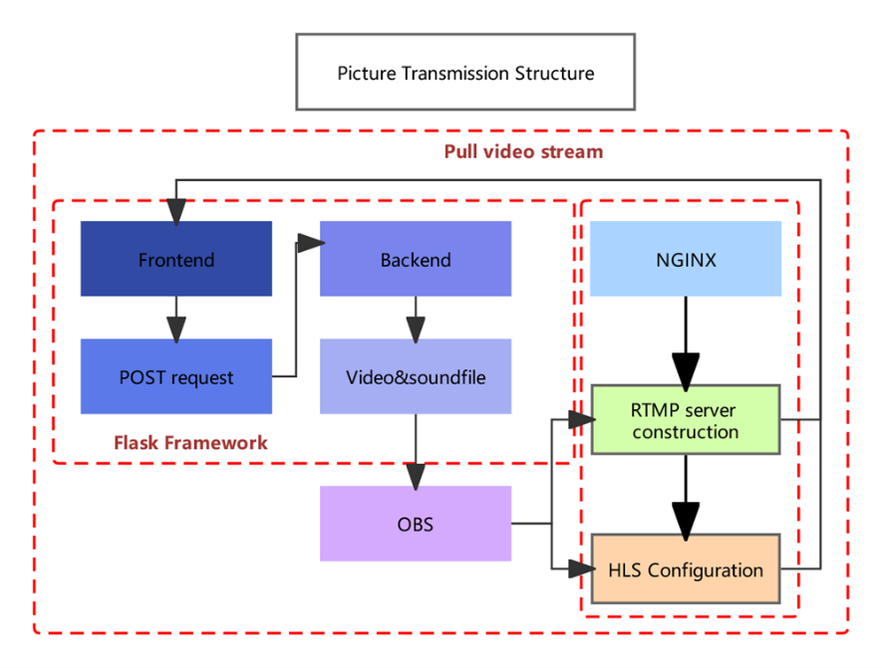

Figure 3-3-2-1 Video streaming structure

Module progress and completion:

1. Nginx dependent installation: Nginx needs to have an rtmp module and be compiled to ensure that the corresponding ports of the server (1935 for RTMP and 8080 for HTTP by default) have been opened in the firewall, as shown in the figure The recommended installation version:



Figure 3-3-2-2 Nginx version

2. Configure the nginx file for live streaming: enable HLS in the corresponding RTMP application configuration and specify the path of the HLS file storage. Configure an HTTP server to support HLS playback. The profile code is as follows:

worker_processes 1;

events {

worker_connections 1024;

}

rtmp {

server {

1935;# RTMP标准端口

chunk_size 4096;

application live {

live on;

record off;

# Enable HLS

hls on;

hls_path C:\\Users\\13157\\Desktop\\nginx\\temp\\hls;

hls_fragment 10s; # 每个HLS分片的持续时间，单位为秒

hls_playlist_length 30s;

}

}

}

http {

server {

list 8080;

location /hls {

alias C:\\Users\\13157\\Desktop\\nginx\\temp\\hls;

add_header 'Access-Control-Allow-Origin' '*' always;

types {

application/vnd.apple.mpegurl m3u8;

video/mp2t ts;

}

}

}

}

3. Stream ingest key setting: Add a specific path or identifier (i.e., ingest key) to the RTMP URL to distinguish different ingest sources. This is not directly defined in the Nginx configuration file, but is specified when ingesting streams through OBS. The ingest URL is usually in the following format: rtmp:// server_ip/live/STREAM_KEY, in which the STREAM_KEY is a custom ingest key. The following figure shows the configuration of the OBS stream ingest server:

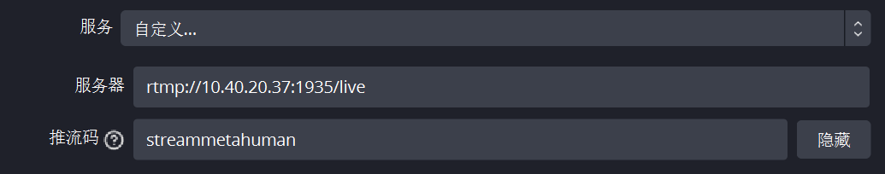

Figure 3-3-2-3 Configuring the OBS stream ingest server

4. After the front-end streaming, the video stream signal of the metahuman can be received normally. However, after testing, it was found that the delay of the video stream signal was large, up to 30s, which seriously affected the user's interactive experience, so it needed to be optimized.

Generally speaking, the latency of HLS-based live streaming may be due to the following two reasons: (1) The duration of the security buffer on the client. The HLS protocol does not recommend that clients select a shard with an EXT-X-TARGET DURATION that is less than twice the duration of the last shard and the duration of the last shard for playback as the first shard. That is, in general, the client should start playback from the third-to-last or fourth-to-last shard in the M3U8 file. (2) The interval at which the server updates the M3U8 file. Theoretically, the hls server needs to have an ext-x-target duration greater than or equal to a duration to update m3u8 files.

We can start with the above two reasons for delay to reduce the latency of live streaming.

hls_fragment 2s;

hls_playlist_length 4s;

Reduce the security buffer time of the client as appropriate. In scenarios where the network environment is superior enough (such as intranet live streaming), the duration of client security buffering can be appropriately reduced. For example hls.js you can modify liveSyncDurationCount and liveSyncDuration (the duration of the security buffer in seconds) to adjust the duration of the security buffer. Reduces the interval at which the server updates the M3U8 file. Try to use the GOP (Group Of Picture) duration to set the duration of sharding to reduce the interval between server updates M3U8 files. And if the server performance and network environment allow, appropriately reduce the length of the GOP (reducing the length of the GOP will lead to low video compression ratio and low transmission efficiency).

5. Evaluation of optimization results: After optimizing the configuration of the server, the transmission delay has been optimized from 30 seconds to 7 seconds, an increase of 77% (as shown in the figure).

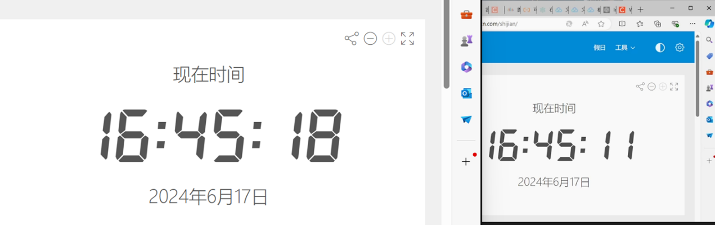

Figure 3-3-2-4 Video streaming optimization renderings

6. Final Effect Demo:

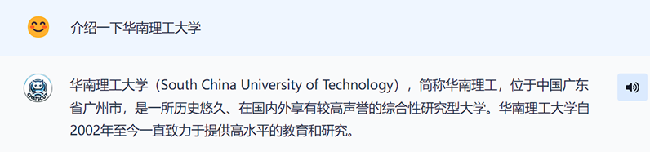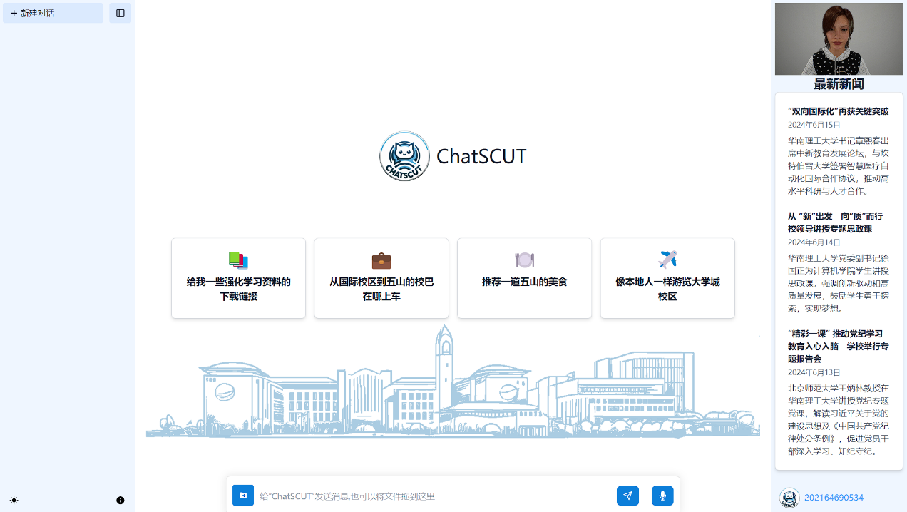

Figure 3-3-2-5 Final rendering

After the front-end pulls the stream, the video stream signal of the metahuman can be received by the front-end normally. Now, after the large model generates a text reply, users can click on the speaker, and users can watch the dialogue of the metahuman with low latency on the web side.

## 3.4 Multi-agent module

### 3.4.1 RAG Agents



Figure 3-4-1-1 Schematic diagram of retrieval enhancement generation agent



Figure 3-4-1-1 ChatSCUT reply

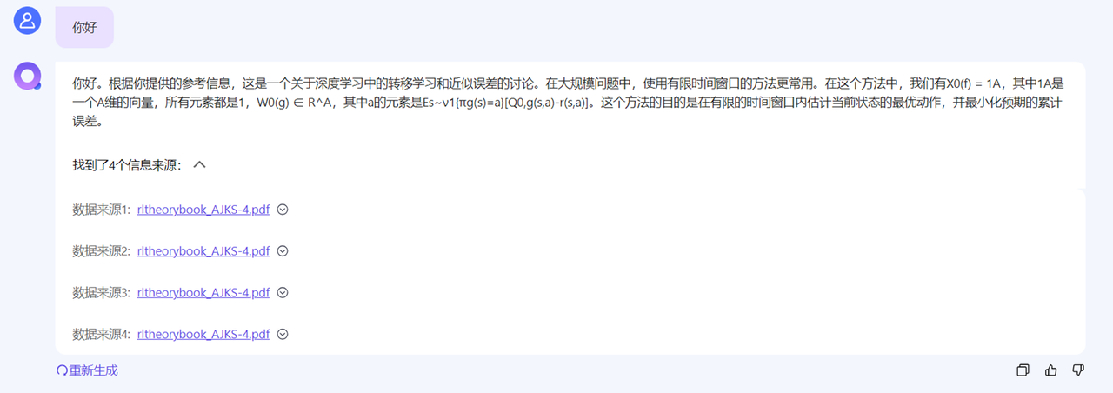

Figure 3-4-1-1 Responses from other products

RAG Agent is an original innovation in the ChatSCUT-Turbo system. In the market, there are also other products that perform RAG (Retrieval Enhanced Generation) based on the user's own input file, such as NetEase's product. However, there are some problems with the practical application of these products: since RAG works by stuffing the retrieved answers directly into the prompt words, this often leads to the content of the answers being disturbed by the retrieved information, resulting in gibberish. Although this approach can improve the system's ability to answer questions in specific domains, it also weakens the ability of large language models (LLMs) to answer questions themselves.

We don't want to lose the function of Chat (conversation) by improving ChatSCUT's ability to solve Scut. Therefore, we decided to use an agent to determine whether RAG needs to be called for retrieval before the user asks a question. The specific process is as follows:

1. User Questions: Questions entered by users are first sent to the RAG Agent.

2. Judgment of RAG Agent: RAG Agent analyzes the user's problem and determines whether a RAG search is necessary. If it is judged that no retrieval is required, the question will be directly transmitted to the subsequent processing module; If required, the RAG Agent calls the retrieval module to obtain relevant information.

3. Avoid interference: Through this judgment process, we can effectively avoid unnecessary information retrieval from interfering with the LLM's ability to answer, and maintain the overall dialogue performance and accuracy of the system.

**Advantages Analysis:**

Maintain LLMs' ability to answer: By judging before the user's question, the LLM is not distracted by unnecessary information retrieval and retains its strong ability to answer questions.

Balance answering and dialogue ability: It can improve the ability to answer in specific fields (such as SCUT data) without losing the flexibility and accuracy of the dialogue system.

Avoid gibberish: Avoid gibberish and improve the relevance and accuracy of your responses by making accurate judgments and invoking RAGs.

The introduction of RAG Agent is a major innovation in our domain-specific information retrieval and answering capabilities while maintaining the overall performance of the ChatSCUT dialogue system. Through this mechanism, we can enhance the performance of the dialogue system in specific fields without losing its original function, and achieve more efficient and accurate answers. This original innovation makes ChatSCUT-Turbo more competitive and promising in the market.

### 3.4.2 Fine-tuning of SCUT's agents

The fine-tuning of ScutAgent and the Retrieval-Augmented Generation (RAG) are important innovations in our intelligent retrieval and answering system. This part mainly solves the limitation that RAG alone cannot provide satisfactory answers when faced with some general and evaluative questions.

(1) The necessity of fine-tuning the model

In practice, we have found that RAG technology alone cannot answer a wide range of questions. There is often no one definitive answer to these questions, and it takes a combination of information and knowledge to answer. For example, when a user asks "the motto of South China University of Technology and its significance", RAG can only retrieve a large paragraph about SCUT, but cannot provide a concise and meaningful answer.

Evaluative questions: These questions require a comprehensive analysis and summary of information, and it is difficult to meet the needs of retrieval techniques alone.

General questions: These questions often involve extensive knowledge and understanding and require a long period of data training and accumulation to answer accurately.

(2) Advantages of fine-tuning the model

By fine-tuning the model, we have greatly improved the system's ability to answer subjective and comprehensive questions. While the fine-tuned model only improved overall accuracy by 3 to 4 percent, it showed a significant improvement in answering subjective questions, which was noticeable to users.

Comprehensive analysis capabilities: Fine-tuning models can comprehensively analyze information from multiple sources to provide more accurate and meaningful answers.

Subjective Problem Handling: The fine-tuned ScutAgent excels at handling subjective issues, providing more insightful and in-depth answers.

(3) Performance analysis and application effect

Fine-tuned results: The fine-tuned model performs well in the face of subjective and evaluative issues, and the user experience is significantly improved.

Combination of RAG and fine-tuning: By combining RAG technology with fine-tuning models, we can not only retrieve information quickly, but also comprehensively analyze and summarize information to provide better answers.

The combination of ScutAgent's fine-tuning and RAG technology is an important innovation in our system. This technology not only improves the accuracy of the system, but also significantly improves the performance of the system when dealing with subjective and comprehensive problems. By fine-tuning the model, we were able to solve the challenge of not being able to address a wide range of problems with RAG alone, providing users with higher quality answers and a better experience.

### 3.4.3 Summarizing agents

In the final part of our system, the output of the ScutAgent and the output of the RAG will be jointly handed over to the SumAgent for summary and output. This integrated approach ensures that we are able to leverage the strengths of each component to provide users with more accurate and comprehensive answers.

(1) Integration of ScutAgent with RAG

To ensure comprehensiveness and accuracy of the answers, we have integrated the output of ScutAgent and RAG. ScutAgent is fine-tuned to handle subjective and evaluative issues, while RAG quickly retrieves relevant information. In this way, we can not only obtain information quickly, but also analyze and synthesize it in depth.

ScutAgent: It is good at handling subjective questions that require comprehensive analysis to improve the depth and quality of answers.

RAG: Quickly retrieves relevant information and provides basic data support.

（2）SumAgent

The SumAgent is responsible for synthesizing and summarizing the output of the ScutAgent and RAG to generate the final answer. In this way, we are able to maximize the strengths of both technologies to provide higher quality answers.

## 3.5 Large language model module

### 3.5.2 Base model



Figure 3-5-2-1 Selecting a base model

When selecting the base model, we look for a large language model that can support Chinese and English (the model cannot be a large language model without Chinese dataset pre-training like the llama model, and must have the ability to adapt to Chinese), have a certain context window capability (a larger context window can provide richer semantic information, so that the model can make more accurate predictions or generation according to the foregoing), and can be deployed on a single GPU (the parameter scale below 7B, if the number of selected model parameters is too large, We will not be able to do it in a limited time with limited funding).

Qwen-7B, a general-purpose model with 7 billion parameters developed by Alibaba Cloud, was chosen for its excellent performance in multiple benchmarks. The model is pre-trained on data of more than 2.4 trillion tokens, and contains rich data in Chinese and English, multi-language, programming, mathematics, and other fields, ensuring a wide coverage. Considering the limitation of the size of the 7B parameters, we use a structured instruction template in the instruction fine-tuning to enhance the instruction compliance ability of the model in practical applications.

### 3.5.3 Model fine-tuning

With limited funds and computing resources, we successfully implemented LoRa fine-tuning of the model through various optimization methods, and achieved good results.

Train the model: We used the ChatGLM4-9B model to build a large-scale dataset of 2 million words using data in Apache format.

Hardware support: Leverage the A6000 48G GPU for training to ensure that the model can run efficiently despite limited computing resources.

Training steps: After 6000 steps of training, we successfully implemented Lora fine-tuning of the model and improved the performance of the model.

Through these efforts, we have achieved effective fine-tuning of the model on the large-scale dataset we have built, and achieved the desired results. Despite the limited resources, we have been able to optimize the system to ensure efficient operation and output quality.

### 3.5.1 Retrieval Enhancement Generation

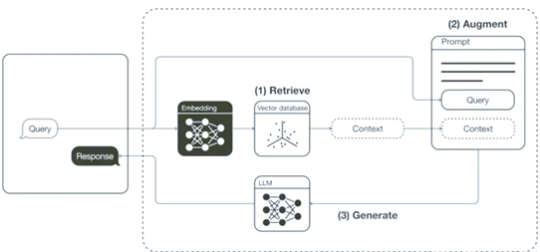

Figure 3-5-1-1 RAG schematic

Retrieval Enhanced Generation (RAG) solves two main problems: how to retrieve and how to generate. The whole can be divided into two phases: the retrieval phase and the generation phase.

In the retrieval stage, the algorithm searches for and retrieves information fragments related to user input, as shown in Step 1 and Step 2 in the figure, and queries the information fragments related to query from the vector database. In the generation phase, Step 3, the large model extracts information based on enhanced prompts and pre-trained internal representations to generate answers tailored to the user.

The overall process of RAG can be divided into the following parts: slicing and quantifying the input text; search in vector databases; Responses are generated from the knowledge gained through the search.

Each section is explained in detail below.

**(1) Vectorization**

Text vectorisation is a method of converting text into a vector representation, allowing the text to be processed by machine learning algorithms. Common text vectorisation methods include Bag-of-Words, TF-IDF (Term Frequency-Inverse Document Frequency), Word Embeddings and Contextual Embeddings.Embedding is a bit like a dictionary that converts different words, images, or objects into unique numeric encodings. This allows us to use these numbers to calculate, categorize, or make predictions. With embedding, a computer can become smarter because it learns how to understand and process a wide variety of data with numbers.

For example, we can use a vector of numbers (x1, x2, x3, ..., x300) to represent a word, where each number is the coordinate of the word in a sense. For example, if we describe the word "cat", it can be (1, 0.8, -2, 0, 1.5, ...). "Dog" can be expressed as (0.5, 1.1, -1.8, 0.4, 2.2, ...). We can then calculate how close the semantic relationship between "cat" and "dog" is by the distance of these numbers. Because they will be closer in some numbers. The distance from the vector of the "table" is even farther away.

In this way, embedding gives vocabulary a mathematical representation, and the computer can analyze the relationship between words.

Implementation:

Currently, there are a variety of open-source embedding models to choose from. In the actual progress of the project, we chose the m3e-base model. M3E is an abbreviation for Moka Massive Mixed Embedding.

Moka: This model was trained, open-sourced and evaluated by MokaAI. For evaluation, uni-emb was used in the training script and MTEB-zh was used in the evaluation BenchMark.

Massive: This model trains the dataset with tens of millions (2200w+) of Chinese sentences.

Mixed: This model supports functions such as homogeneous text similarity calculation and heterogeneous text retrieval in Chinese and English, and code retrieval in the future.

Assessment Results:

We took a small number of samples from the established SCUT dataset to evaluate the results of various embedding models, and the results are shown in the following figure:

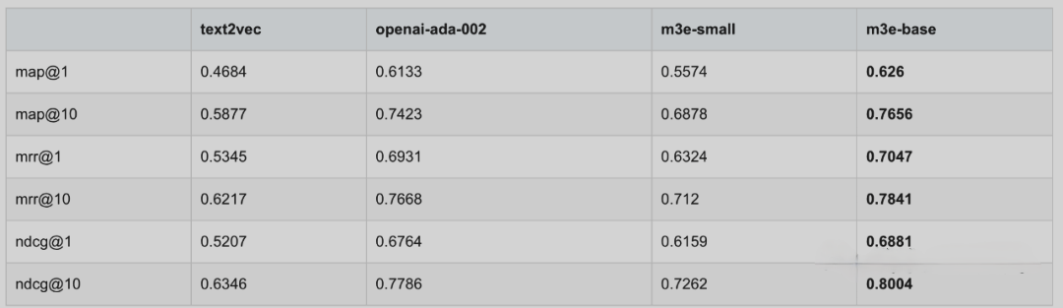

Figure 3-5-1-2 Vectorized evaluation results

It can be seen that the indicators of the m3e-base model are better than those of other embedding models.

**(2) Data retrieval**

In a Retrieval Enhanced Generation (RAG) system, vector matching involves converting a text query into high-dimensional vectors and comparing these vectors to a pre-indexed database of document vectors. The aim is to identify the most relevant documents to support the generation of accurate and contextual responses. In this way, the RAG system enhances the foundation of the generated model in real-world information, thereby improving the relevance and accuracy of the output.

Implementation:

Similarity search with relevance scores

At the heart of the vector matching implementation is the similarity_search_with_relevance_score_by_vector method, which extends the FAISS similarity search by introducing a relevance scoring function:

class Faiss(FAISS):

def similarity_search_with_relevance_score_by_vector(

self,

embedding: List,

k: int = 4,

filter: Optional = None,

fetch_k: int = 20,

relevance_score_threshold=None,

**kwargs: Any,

):

relevance_score_fn = self._select_relevance_score_fn()

...

Abstract multi-level search

def search_by_abstract(

self,

query: str,

topk_abstract: int,

topk_knowledge: int,

knowledge_threshold=None,

) -> SearchResult:

t0 = time.process_time()

# In the first stage, abstract search, the search results are sorted by score from largest to smallest

query_emb = self.embedding_model.embed_query(query)

abstracts_with_scores = (

self.abstracts_store.similarity_search_with_relevance_score_by_vector(

embedding=query_emb,

k=topk_abstract,

)

)

# In the second stage, search in the body of a similar abstract

docs_with_scores = []

for abstract, _ in abstracts_with_scores:

docs_with_scores.extend(

self.stores[

abstract.metadata["file_name"]

].similarity_search_with_relevance_score_by_vector(

embedding=query_emb,

k=topk_knowledge,

relevance_score_threshold=knowledge_threshold,

)

)

if len(docs_with_scores) == 0:

return SearchResult()

t1 = time.process_time()

# Search results are sorted by score from highest to smallest

docs_with_scores = sorted(docs_with_scores, key=lambda x: -x[1])[

0:topk_knowledge

]

**(3) Generate answers based on the search**

During the data generation phase, the RAG model leverages retrieved pieces of information and a pre-trained generative model to generate responses. The generative model generates contextual natural language responses based on enhanced prompts and internal representations of the inputs.

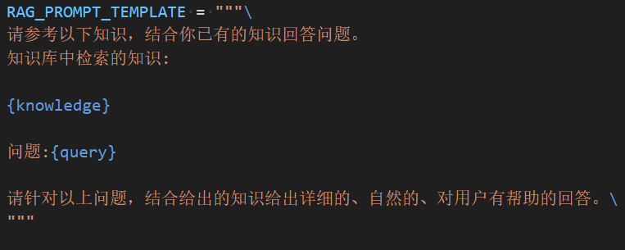

Figure 3-5-1-4 Prompt template

This is the prompt template we use, and the retrieved knowledge is put into a fine-tuned model along with the question to generate the answer.

In order to achieve the integration of RAG systems, we use the following technologies and methods:

We use FAISS to build a vector database for storing and retrieving documents represented by high-dimensional vectors.

Use a web crawler to scrape the latest information from the school's official website on a regular basis. The crawler automatically recognizes and downloads newly published documents and updated content. The newly captured data is automatically cleaned and vectorized and then updated directly to the database used by the RAG system, without the need to shut down or restart the server. This is done by invoking a specific agent that handles the insertion of new data and the update of old data, ensuring that the system can still provide services during the update process.

### 3.5.4 Multi-level abstract search

**(1) Innovation and optimization of multi-level abstract retrieval strategies**

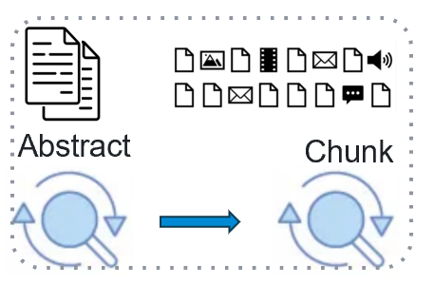

Figure 3-6-1-1 Schematic diagram of multi-level abstract search

If you decide that you need to use a search, the next step is multi-level abstract search, and we have two innovations here:

In the middle of the system's development, we initially divided all the data into chunks every 200 words and encoded them directly into the database. However, as the amount of data continues to increase, we find that RAG (Retrieval-Augmented Generation) performs worse and worse when retrieving correct answers. This problem prompted us to look for a more efficient solution.

**Problem Analysis and Challenges:**

The amount of data increases: As the amount of data in the database increases, the retrieval performance of RAG gradually decreases, and the match rate of correct answers becomes unsatisfactory.

Reduced retrieval efficiency: Traditional RAG methods significantly reduce retrieval efficiency in the face of large datasets, resulting in poor user experience.

**Innovative solution: Multi-level abstract search**

In order to solve the above problems, we designed and implemented a multi-level abstract retrieval strategy. This innovative approach significantly improves the retrieval performance and accuracy of the system.

1. Preliminary abstract search

Summary generation: First, we generate summaries for each document that concisely summarize the main points of the document.

Preliminary matching: When a user asks a question, the system retrieves these summaries first to quickly locate the scope of documents related to the issue.

2. Secondary detailed search

Narrowing the scope: With the preliminarily matched abstracts, the system further narrows the scope of the search, thereby reducing the noise of irrelevant information.

Fine-grained search: In the narrowed range, the system conducts a detailed search and indexes out the specific answers that best match the user's question.

**Performance improvement analysis**

Improved search efficiency: The multi-level abstract search strategy significantly improves the search efficiency of the system by gradually narrowing the search scope in stages.

Improved accuracy: Through the combination of primary abstract search and secondary detailed search, the system can more accurately locate and match user questions, and improve the accuracy of answers.

Enhancement of big data processing capabilities: It can be clearly seen from the figure that with the continuous expansion of databases, multi-level abstract retrieval is significantly better than traditional RAG methods in terms of performance, showing stronger big data processing capabilities.

The multi-level abstract retrieval strategy is an important innovation for us to cope with the growth of data volume and improve search performance. Through this strategy, we not only solve the performance bottleneck of traditional RAG in the big data environment, but also significantly improve the retrieval accuracy and user satisfaction of the system. This innovative approach ensures that the system can efficiently and accurately provide users with the answers they need in the face of massive amounts of data.

**(2) Implementation and optimization of Rerank technology**

In addition to constructing high-quality abstract datasets, we also implemented the Rerank technology to further improve the accuracy of searches.

Introduction to Rerank Technology: Rerank technology can re-rank preliminary search results through vector matching with Attention mechanism, so as to improve the accuracy of search results.

Accuracy improvement: With Rerank technology, our system can improve the search accuracy by about 5 percentage points. However, this technique also adds about 13 seconds to the processing time.

User Experience Optimization: Although Rerank technology can significantly improve accuracy, in order to optimize the user experience, we decided not to use this technology in practical applications for the time being, so as to ensure that users can get answers quickly.

Optimization of Rerank technology: By introducing Rerank technology, we have successfully improved the search accuracy. However, in order to optimize the user experience, we put this technology on hold for the time being, weighing accuracy and response time in practical applications.

## 3.6 Dataset module

### 3.6.1 Data Collection

In order to construct a comprehensive and comprehensive large model dataset in the field of campus Q&A, we mainly collected data from the following three aspects:

(1) Documents on the official website of SCUT:

We collected all the documents from the official website of South China University of Technology and the official websites of each college, and collected a total of 16,367 files with a total file size of 3.28 GB and a total word count of 2,140,419 words. These documents include information such as the organizational structure of the college, the postgraduate re-examination plan, and the introduction of the supervisor. For example, part of the documents of the Institute of Future Technology, including the organization of the college, the re-examination of graduate students, the introduction of supervisors, etc.

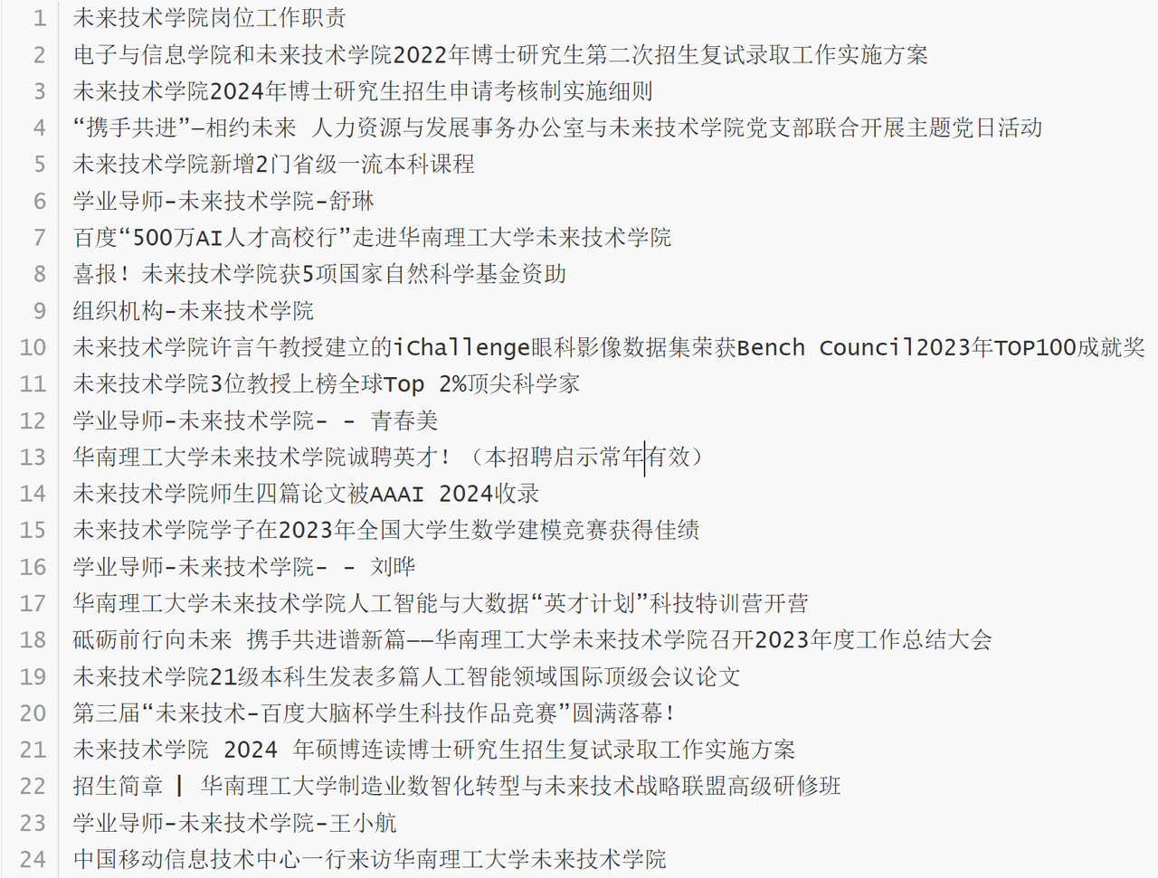

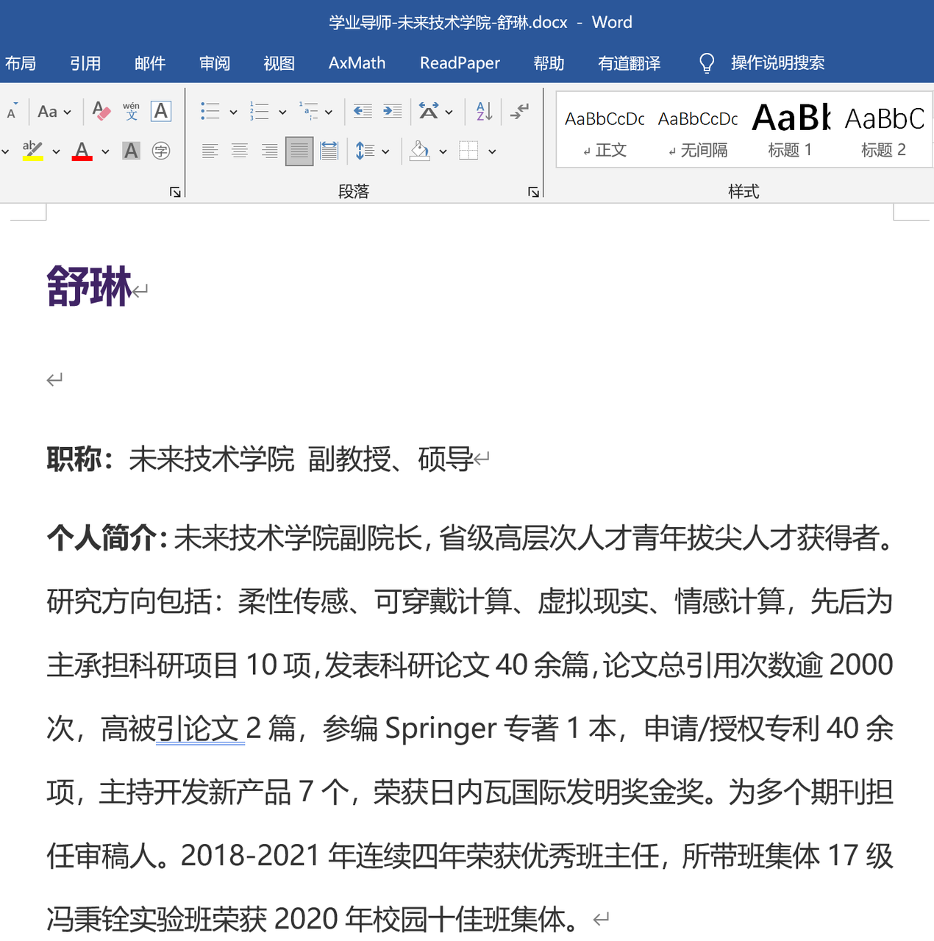

Figure 3-6-1-1 Example of a document on the official website of SCUT

(2) High-quality Q&A dataset of SCUT:

We constructed a dataset of 7,260 high-quality Q&As with a total word count of 1,497,166 words. The content covers all aspects of students' life in South China University of Technology, including comprehensive assessment, scholarship conditions, course selection suggestions, campus daily life, canteen information, class schedules, shopping, transportation, network maintenance, college introduction, and sports facilities. For example, the Q&A of the comprehensive test information includes a detailed explanation of the scholarship application requirements and the percentage of grades ranked.

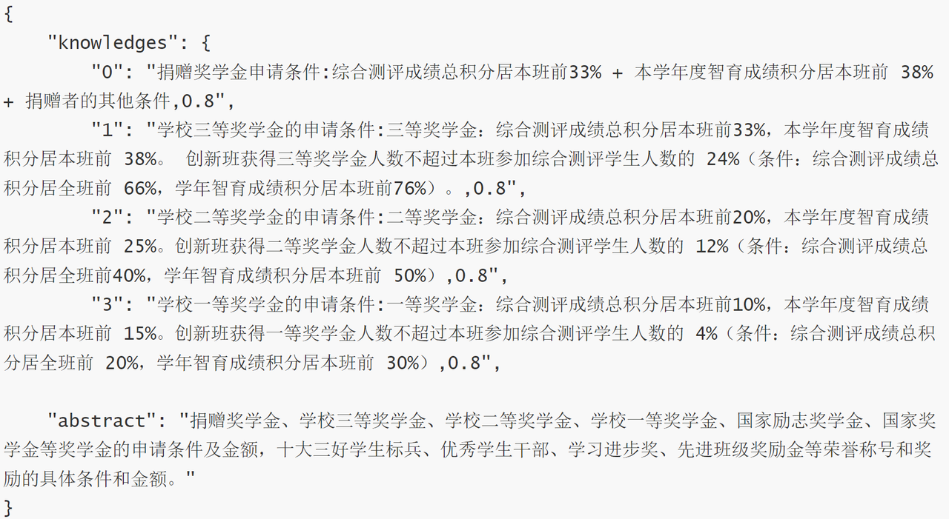

Figure 3-6-1-2 Example of high-quality Q&A by SCUT

(3) Learning materials for SCUT:

We have collected links and extraction codes for a large number of learning materials, covering subject physics experiments, statistical learning methods, digital system design, computer networks, optimization methods, deep learning, and other course content. These learning materials provide students with a wealth of learning resources, further enhancing the usefulness and comprehensiveness of our datasets.

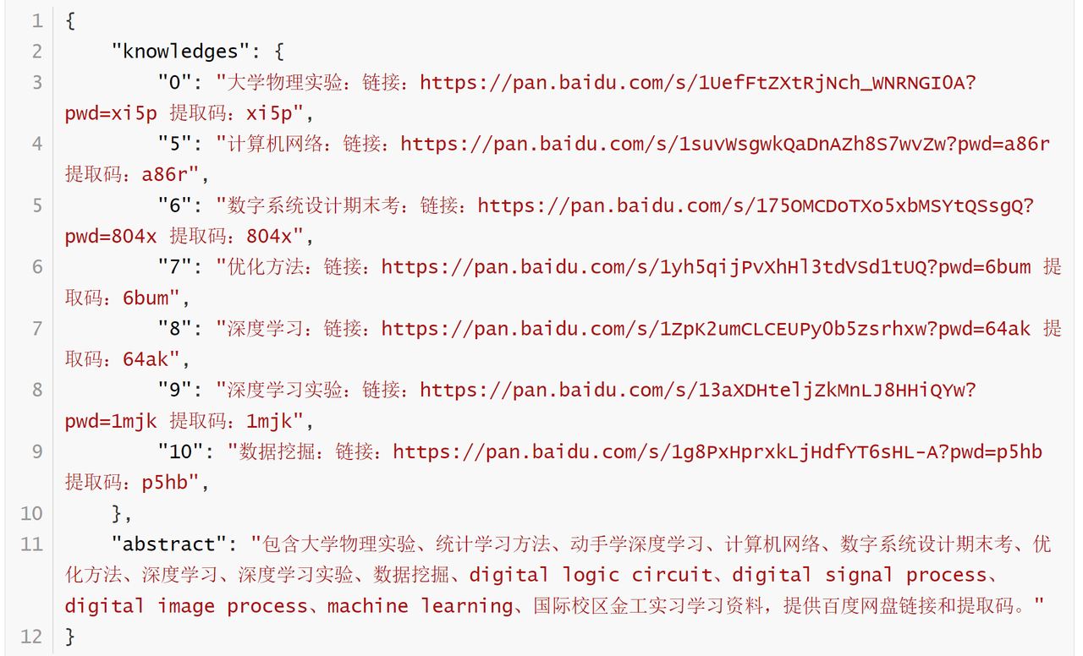

Figure 3-6-1-3 Example of learning materials for SCUT

**Data preprocessing**

Data pre-processing is a key step to ensure data quality and consistency, and we process the collected data as follows:

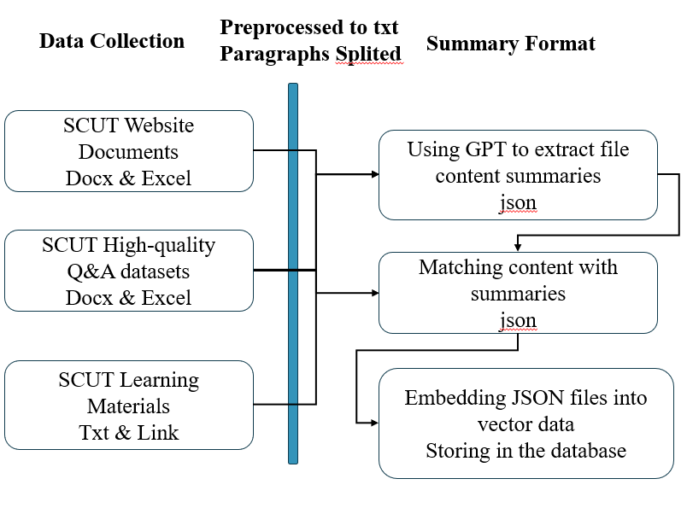

Figure 3-6-1-4 Example of document content

(1) Format conversion:

All collected DOC and PDF documents are pre-processed into TXT format, including processing images, tables and punctuation information to ensure data uniformity and readability.

(2) Text segmentation:

Slice the converted text into paragraphs of less than 200 words for subsequent processing and analysis.

(3) Abstract:

The GPT model was used to organize the contents of each cleaned file into a summary summary of about one-tenth of the original content. This step helps you quickly index and retrieve relevant information.

(4) Data storage:

The above processed data is stored in the FAISS database for efficient vector retrieval and rapid response to user queries. Through these steps, we successfully constructed a comprehensive and rich large model dataset in the field of campus Q&A, which provided a solid foundation for subsequent model training and optimization.

**Auto-update function**: In order to ensure the up-to-date and accurate data, we have implemented the auto-update function. Use a web crawler to scrape the latest information from the school's official website on a regular basis. The crawler automatically recognizes and downloads newly published documents and updated content. The newly captured data is automatically cleaned and vectorized and then updated directly to the database used by the RAG system, without the need to shut down or restart the server. This is done by invoking a specific agent that handles the insertion of new data and the update of old data, ensuring that the system can still provide services during the update process.

### 3.6.2 Generate summary of SCUT' documents

**Original innovation and implementation of constructing summary datasets**

Constructing a high-quality summary dataset is an important part of original innovation in our system design. To achieve this, we generate an accurate summary of each document and use an agent to do this efficiently.

**Original innovation: Construct high-quality summary datasets**

To ensure that the system can locate relevant information quickly and accurately, we constructed a summary dataset of 16,000 documents. Each document is finely processed to produce high-quality summaries that effectively summarize the core content of the document, improving the accuracy and efficiency of retrieval.

Intelligent summary generation: We utilize Agent technology to generate a summary for each document. With this approach, we efficiently processed 16,000 documents and generated an accurate summary of each document.

Improve retrieval efficiency: Constructing high-quality abstract datasets not only improves the retrieval efficiency of the system, but also improves the accuracy of the retrieval results, providing users with better services.

Construction of summary datasets: Constructing high-quality summary datasets enables our system to locate relevant information quickly and accurately, which greatly improves retrieval performance.

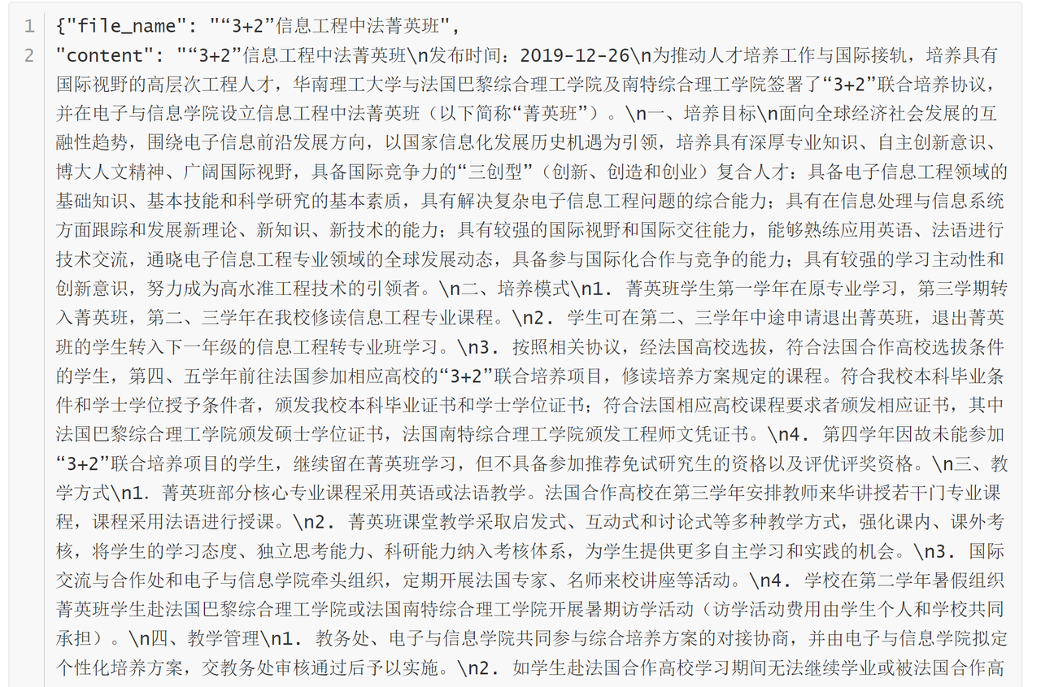

Figure 3-6-2-1 Example of document content

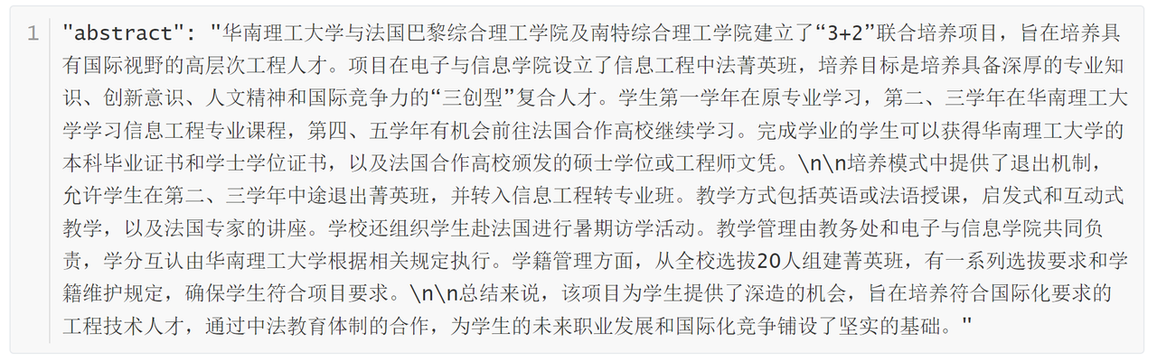

Figure 3-6-2-2 Example of abstract content

### 3.6.3 Fine-tune the construction of the dataset required for the model

In order to fine-tune and optimize the system, we use the Format Agent to build a high-quality Q&A dataset. These datasets not only contain questions and answers from users, but are also finely formatted to ensure data quality and consistency.

Application of Formatting Agent: By formatting the Agent, we can automatically process and generate high-quality Q&A data. This technology greatly improves the efficiency and accuracy of data processing.

High-quality Q&A dataset: We built a high-quality training dataset with 2 million words. This data is presented in the form of user questions and answers, ensuring the usefulness and reliability of the data.

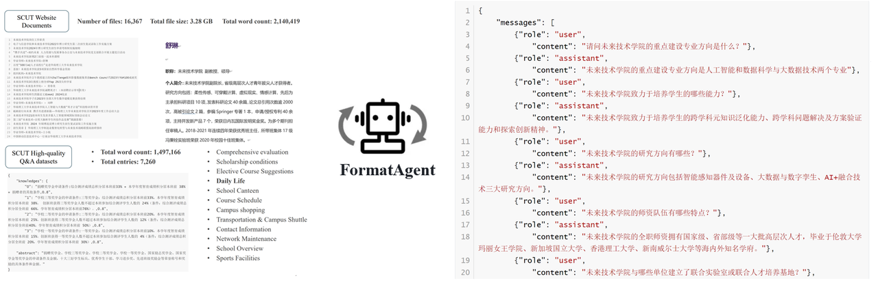

Figure 3-6-3-1 Schematic diagram of formatting agents

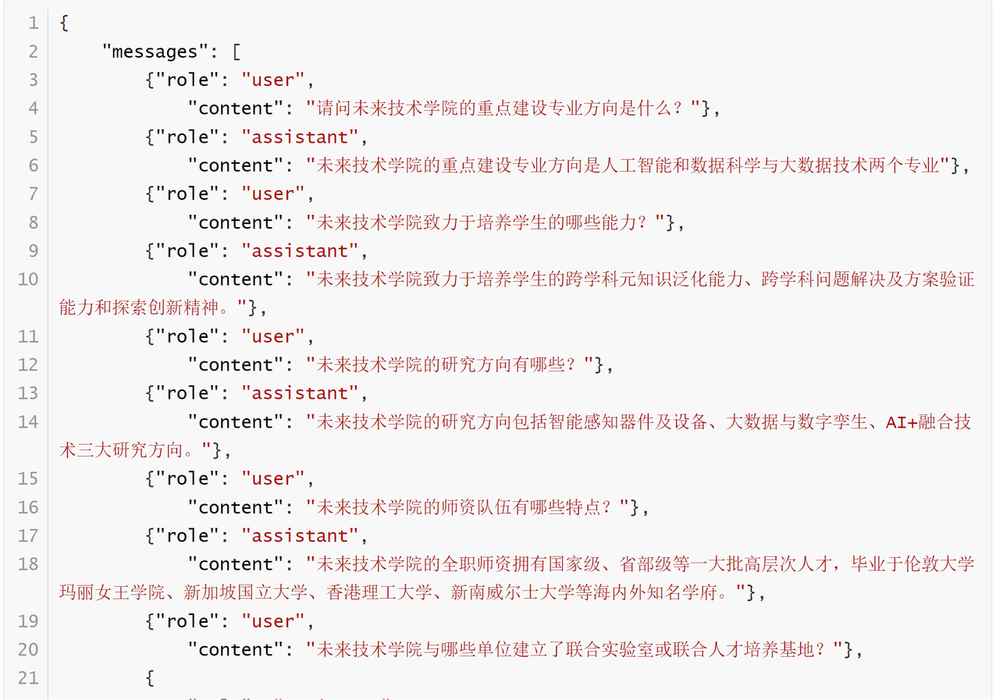

Figure 3-6-3-2 Example diagram of fine-tuning dataset

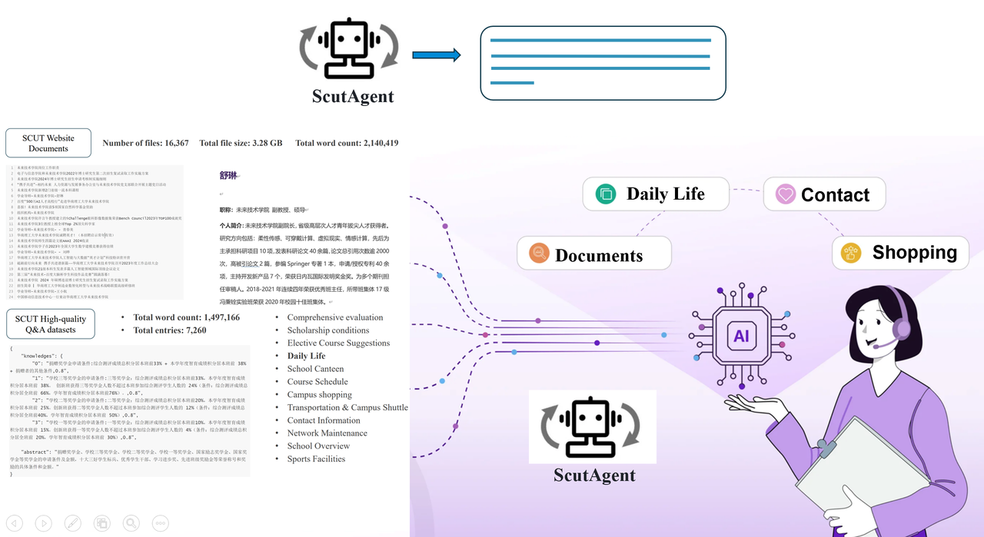

Figure 3-6-3-3 Schematic diagram of the agent of SCUT

### 3.6.4 Construction of news dataset on the official website of SCUT

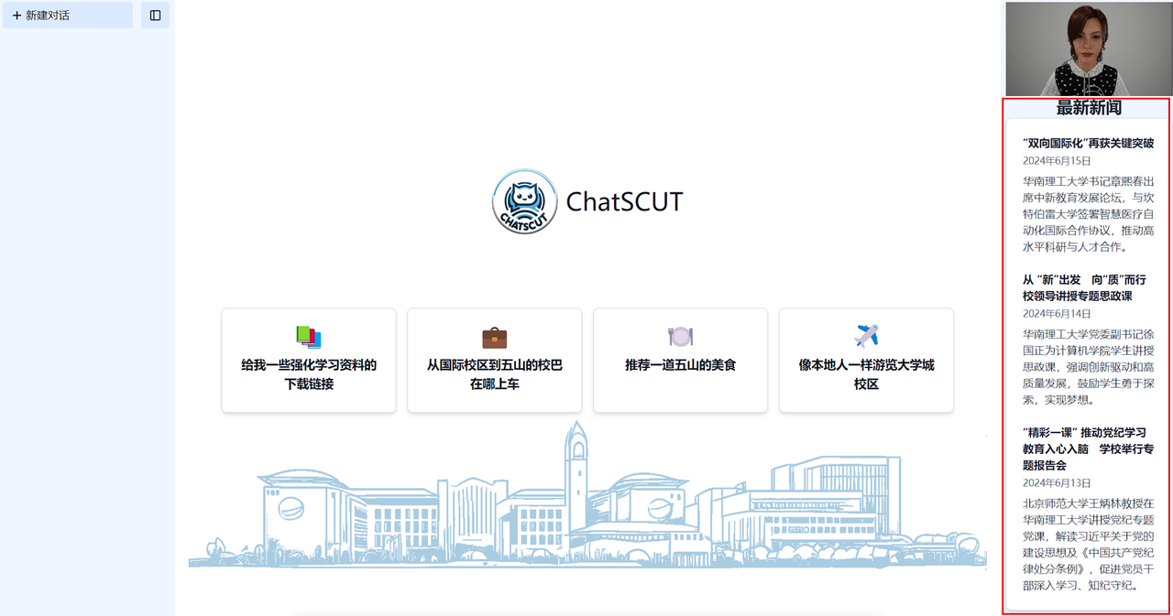

Figure 3-6-4-1 Schematic diagram of the latest news of SCUT

The latest news of our SCUT is placed in the right area, which effectively fills the blank problem on the right side and makes the picture beautiful, and the latest news includes news headlines, release time, and news summary.

(1) Web crawling part

During the development of the system, Dean Shu asked us to build an extensive dataset at the very beginning. On the timeline, we have collected a large amount of historical Chinese labor data. However, we are not only satisfied with the accumulation of historical data, but also hope to continue to update and collect future data of SCUT. Therefore, we have realized the function of automatically crawling the latest news information of SCUT.

(2) Automatic crawling and data updates

In order to get the latest news in real time, we have developed an automated web crawling system. This system can regularly scan the official website of SCUT and related news websites to automatically capture the latest news content. In this way, we ensure that the dataset is updated in real time, always keeping the most up-to-date information on hand.

(3) Use the Agent to summarize the news

In order to make it easier for users to read and use, we have introduced an agent to summarize the news content. The agent automatically extracts key information from the news and generates concise news summaries. The resulting news digest is not only convenient for users to quickly keep up to date, but also easy to store and manage.

(4) Update the vector database

The crawled news data is summarized by the agent and not only published on our website, but also automatically updated to the vector database. The update of the vector database ensures that the RAG (Retrieval-Augmented Generation) system can retrieve the latest data in a timely manner, providing users with the most up-to-date and comprehensive information support.

**System process:**

1. Web crawling: Automatically crawl the latest news from the official website of SCUT and related news websites.

2. Agent Summary: Use the intelligent agent to summarize the crawled news and generate a concise news summary.

3. Publish news: Publish the generated news summary on our website for users to browse.

4. Database Update: Update news data into a vector database to ensure real-time data support from the RAG system.

Through this series of processes, we not only realize the accumulation of historical data, but also ensure the real-time update and expansion of data sets, providing users with richer and more timely information services.

## 3.7 Vector database module

### 3.7.1 Vector database construction

Our system has significant advantages in terms of file processing and encoding speed, which is a major competitive advantage for us compared to other products. For example, some other products on the market take a long time to encode files into a vector database, such as a 200-page student handbook, which can take up to 20 minutes to get an answer. Our system only takes about two minutes to accomplish the same task. This significant difference is largely due to our innovation in technology and deployment.

We use GPU deployment algorithms in the process of file processing and encoding. This efficient hardware acceleration can significantly speed up the execution of OCR (Optical Character Recognition) and other algorithms. In contrast, other products may still be using CPUs to run these algorithms, resulting in significantly slower processing speeds.

### 3.7.2 Dynamically update the vector database

In our system, dynamically updating the vector database is an important feature worth mentioning. Due to the large number of documents we have, with a total of 16,000 documents, if each document takes 1 second to process, it will take about 4 hours to fully update the database once. Obviously, this approach does not meet the need for real-time updates.

(1) Add dynamic update function:

To address this challenge, we have developed the ability to dynamically update the database. This feature allows the system to incrementally update the new data without having to rebuild the entire amount of data. This not only greatly reduces the data processing time, but also ensures the real-time and accuracy of the database.

(2) Achieve daily automatic updates:

Thanks to the dynamic update database function, our system can automatically extract the latest data of SCUT and store it every day. This feature ensures that the data in the vector database is always up-to-date, providing users with timely and accurate information support. The automatic daily updates not only improve the operational efficiency of the system, but also enhance our development experience.

(3) The necessity of background improvement:

While most of these improvements are focused on background processing and aren't particularly noticeable on the front-end, they are all very necessary and effective. The dynamic update database function greatly improves data processing efficiency and avoids time waste and system load caused by full reconstruction. At the same time, the back-end improvement also provides a solid foundation for the stable operation of front-end functions and the improvement of user experience.

(4) System process:

1. Add data: The system automatically detects and extracts new data.

2. Dynamic update: Incremental updates are performed on the new data to avoid full reconstruction.

3. Daily automatic update: The system automatically extracts and updates the latest data every day to ensure the real-time performance of the database.

4. User support: The dynamically updated database provides users with the most up-to-date and accurate information support.

Through this series of optimization measures, we not only realize the real-time update of data, but also greatly improve the operational efficiency of the system. Although these back-end improvements are not directly perceived by users, they are the key to the stable and efficient operation of the system, which greatly enhances our overall service capabilities.

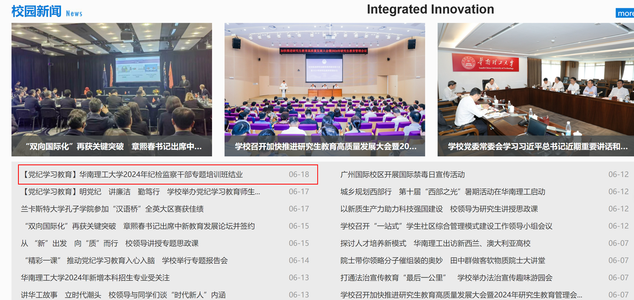

Figure 3-7-2-1 Schematic diagram of news sources

## 3.8 Front-end module

 

Figure 3-8-1 Technical scheme diagram

The front-end module mainly uses modern front-end frameworks react and next.js uses React's component-based design and state management to achieve a dynamic and responsive user interface, and improves page load speed and SEO performance through Next.js server-side rendering (SSR) and static generation (SSG).

The specific results of the front-end are as follows:

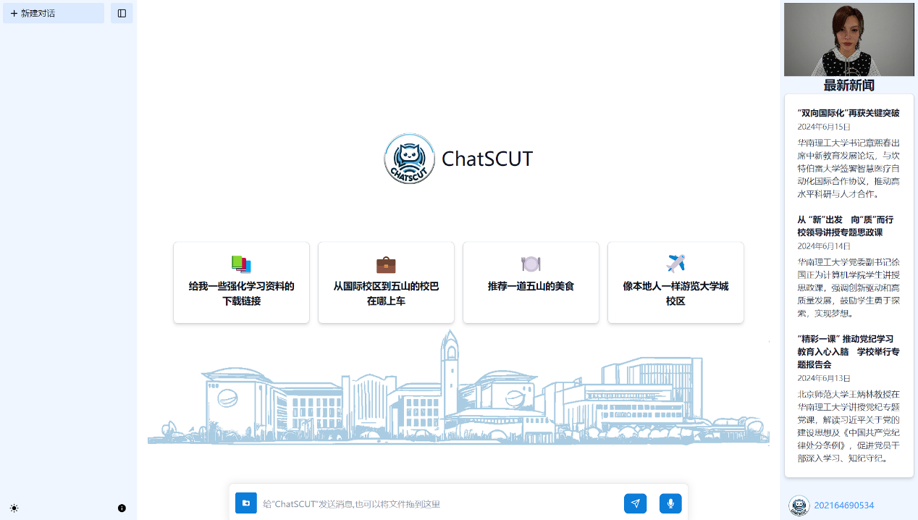

Figure 3-8-2 Front-end specific results

It is mainly divided into 5 modules: the login module, the chat list module on the left, the message display module and the message input module in the middle, and the digital person display module on the right. Each of the five modules is described below.

### 3.8.1 Overall Architecture

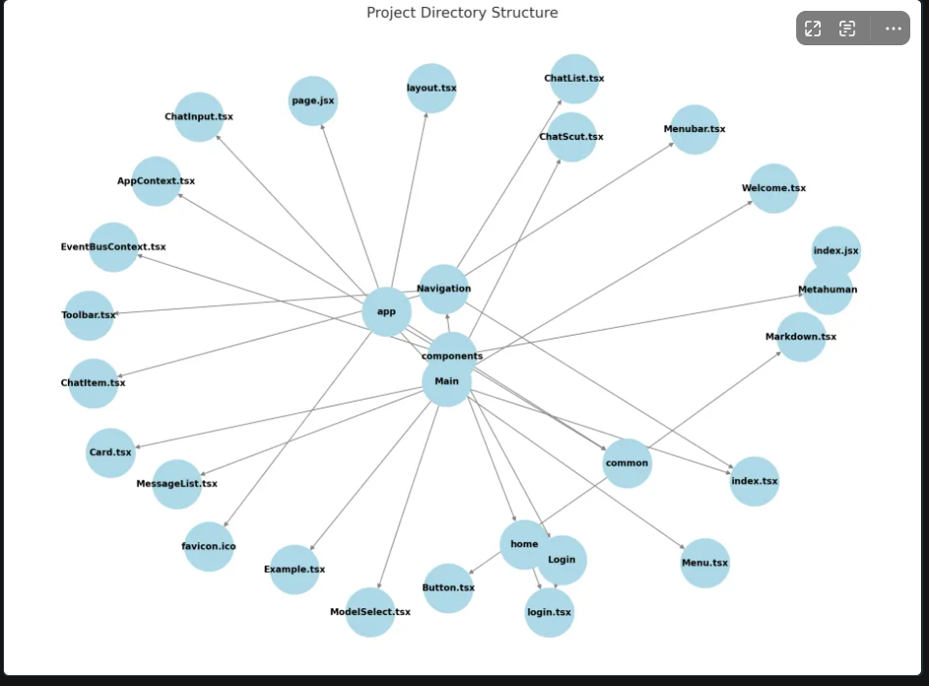

Figure 3-8-1-1 Front-end framework diagram

This is the overall architecture diagram of the project, and the basic idea of react is component is everything, so basically all the functional implementations in this project are based on component. The entire front-end is made up of four components: Navigation, Main, Metahuman, and Login, which in turn are made up of other small components.

Based on the basic idea of React, we can get the optimal construction method of the React project, that is, write the static web page part of the component first, and then write the information transfer logic between the components. The most important thing in information transmission is the design of various information data structures, and the data structures used for information transmission are introduced next.

export interface Chat {

chatId: string

description: string

time:number

}

export interface ChatDTO {

chatid: string

description: string

time:string

user:string

}

export interface Message {

id: string

role: "user" | "assistant"

message: string

chatid:string

time: string

}

export interface MessageRequestBody {

messages: Message[]

model: string

}

export type State = {

user:string

displayNavigation: boolean

themeMode: "dark" | "light"

currentModel: string

messageList: Message[]

streamingId: string

selectedChat?:Chat

message:string

chatList:Chat[]

}

These five types of data structures cover most of the data transfer in the entire front-end project:

(1) Chat is a chat information in the chat list, only the ID of the chat and the title of the chat are saved here, and all the records of the chat are not saved. This is because saving all the chats consumes a lot of memory and makes the database more frequent. The design here is to balance space and time, only store the chat list locally, and if you want to access a specific chat history, you can request it directly from the backend.

(2) ChatDTO is a data structure specially used to transmit messages to the backend, and when the front-end wants to transmit a Chat to the back-end, it must first convert it into a ChatDTO before it can be transmitted.

(3) Message is a message in the chat, which stores a message in the chat, including the content of the message and who sent the specific message, as well as the time when the message was sent.

(4) MessageRequestBody is a data structure that transmits a list of messages to the backend.

(5) State is the global information of the entire front-end, which includes the current user, all messages of the current chat, the current chat, the current message to be sent, and all the current chats. Various functions of the front-end can be realized by manipulating the State.

### 3.8.2 Login Module

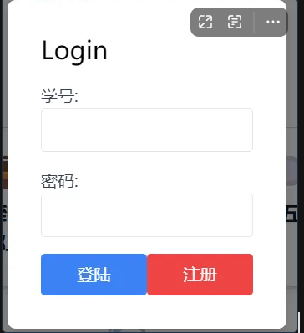

Figure 3-8-2-1 Login module

The specific display of the login function is shown in the figure above, the user enters the student number and password, and clicks the login button to log in to detect, and clicks the register button to register.

async function check(){

const body = JSON.stringify({

"id":username,

"password":password,

})

const response = await fetch("http://10.40.20.16:8080/login",

{

method:"POST",

headers:{

"Content-Type":"application/json"

},

body:body,

}

)

const responseData = await response.json();

if (responseData.success){

onLogin();

dispatch({type:ActionType.Login,value:username})

}

else{

alert("Login failed")

}

}

The implementation of the login function is relatively simple, and the specific code is as follows. The logic is to transmit the code entered by the user to the login interface of the backend, and the backend will compare the username and password with the database, and then return the result to the frontend. The registration function is to call another regist interface, first check whether there is the same account in the database, and if not, add the user password pair to the database.

### 3.8.3 Chat List Module

The chat list module is mainly used to select chats and some other functions. Click on a specific chat to enter the chat, and the message display module will display the message of this chat. Click New Conversation at the top to exit the current chat and enter the initial state.

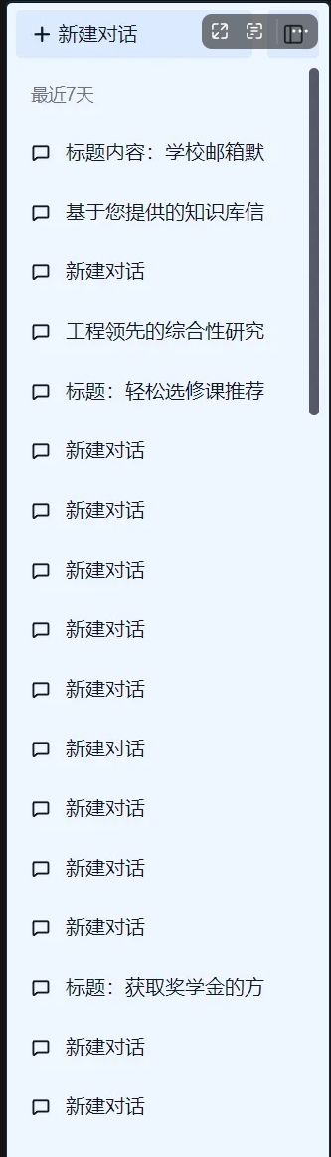

Figure 3-8-3-1 Chat list diagram

When you click on this chat, two buttons will appear on the far right, Modify Title and Delete Chat, and click these two buttons to achieve the corresponding function.

async function getChatlist(){

if(user=="") return

const response = await fetch(

http://10.40.20.16:8080/chat/${user}

,{

method:"POST",

headers:{

"Content-Type":"application/json"

},

}

)

const responseData = await response.json();

const list = (responseData["data"]) as Chat[];

console.log(list)

setChatList(list)

}

useEffect(()=>{

getChatlist();

console.log(chatList)

},[user,selectedChat])

The first thing to introduce is the implementation of getting the chat list, which is actually to call the corresponding interface to obtain information. The more important thing is when to call this function, it is obvious that it should be called when the user successfully logs in, and it should be called when the current selected chat changes, the reason for this design is that we want all data processing to stay in the backend, and the front-end only needs to send and receive data, so when the user creates a new dialog that the database does not have, what the front-end will do is send this conversation to the back-end and let the back-end save it. At this point, the front-end needs to access the database again to get the latest chat list. And this condition is that the current conversation has changed.

Changing the title of the chat and deleting the chat is basically the same logic, so I won't go into too much detail.

The implementation of the new dialog is to set the currently selected dialog to empty, so that the message display module will not display the dialog but the initial page.

### 3.8.4 Message input module

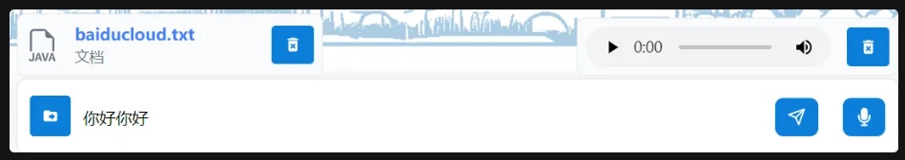

Figure 3-8-4-1 Message input module

Users can enter text messages by typing, upload files by clicking the file upload button or dragging the file into the input box, or click the record button to upload the file by voice.

The text input module is relatively simple, that is, it directly corresponds the text in the text box to the variable.

File input is also relatively simple, the input tag in HTML comes with the input of the file, that is to say, the file can be uploaded directly, and the data type file is also brought in Typescript, which is directly uploaded and saved to the variable. Finally, the file is saved in formdata when sending. FormData is an object used to construct and format data to be sent to a server, typically when submitting data through an HTML form. It allows you to easily manipulate and send form data via JavaScript without having to refresh the page. The FormData object can be used with the XMLHttpRequest and Fetch APIs to send key-value pair data via a POST request.

Voice input calls the mediaRecoder library that comes with javascript, and it will generate a temporary file that can be transferred during transfer.

async function send(content:string) {

Awite changetnwasate()

const responseData = await vsend()

const audio = responseData.audio || ""

const message: Message = {

id: uuidv4(),

role: "user",

message: content + audio,

chatid:chatIdRef.current,

time:getCurrentTimeInUTC8()

}

await send2sql(message)

dispatch({ type: ActionType.ADD_MESSAGE, message })

const messages = messageList.concat([message])

await doSend(messages)

if (!selectedChat?.description || selectedChat.description === "新建对话") {

console.log(messages.length)

if(messages.length>2){

updateChatTitle(message)

}

}

}

After the user enters the message, the front-end will process it and send it to the back-end and the large model side. First of all, the front-end will detect whether the current chat has changed, and then send the file and voice to the large model, which will convert the two into text and return them to the front-end, and the front-end will superimpose the returned text with the text entered by the user, and then send it to the large model to get a reply. When all the above processes are completed, the front-end sends the text to the title generation interface to generate the title.

### 3.8.5 Message display module

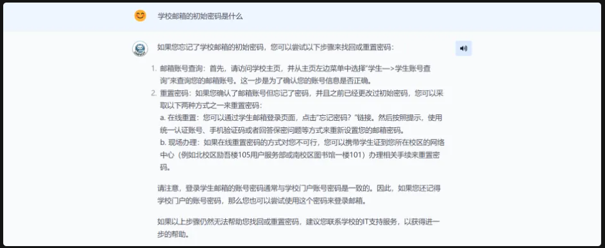

Figure 3-8-5-1 Message display module

After the message is sent, the user's input message is displayed on the screen, and when the large model infers, the output is streamed to the frontend, which can then be displayed on the screen as a streaming output. The user can click the play button on the right to have the metahuman read the text.

<>

{messageList.map((message) => {

const isUser = message.role === "user"

return (

<Li

key={message.id}

className={

${ isUser ? "bg-blue-50 dark:bg-gray-800" : "bg-gray-50 dark:bg-gray-800" }

}

>

<div className='w-full max-w-4xl mx-auto flex space-x-6 px-4 py-6 text-lg'>

<div className='text-3xl leading-[1]'>

{isUser ? "😊" : <div className="my-icon"/>}

</div>

<div className='flex-1'>

<Markdown>{

${message.message}${ message.id === streamingId ? "▍" : "" }

}</Markdown>

</div>

<div>

{!isUser &&

<Button

icon={FaVolumeUp}

onClick={()=>send(message.message)}

>

</Button>}

</div>

</div>

</li>

)

})}

</ul>

The logic here is to display all the information in the global variable messageList, and determine the source of the message through the role in the message. There is no direct implementation of streaming output. In fact, the message returned by the large model is returned word by word, and the value of the last element of the messageList is changed every time a word is returned, and one more word will be displayed at this time, and the streaming output is realized. But this is contrary to our original assumption, we actually prefer not to do the data processing on the front end, but to leave it to the back end. But that adds a lot of interaction with the backend, and now the final logic is a compromise of coupling and complexity.

### 3.8.6 Metahuman display module



Figure 3-8-6-1 Diagram of the metahuman display module

Users can make the metahuman speak by tapping the play button.

React.useEffect(() => {

// Make sure Video.js player is only initialized once

if (!playerRef.current) {

// The Video.js player needs to be

inside

the component el for React 18 Strict Mode.

const videoElement = document.createElement("video-js");

videoElement.classList.add('vjs-big-play-centered');

videoRef.current.appendChild(videoElement);

const player = playerRef.current = videojs(videoElement, options, () => {

videojs.log('player is ready');

onReady && onReady(player);

});

// You could update an existing player in the

else

block here

// on prop change, for example:

} else {

const player = playerRef.current;

player.autoplay(options.autoplay);

player.src(options.sources);

}

}, [options, videoRef]);

Initialize or update the Video.js player with React.useEffect: Create and configure player elements on initial rendering and attach them to the DOM, then update the player's settings based on options. If the component is unmounted, the player is destroyed to prevent memory leaks. Functions rely on changes in options and videoRef to re-execute.

## 3.9 Back-end module

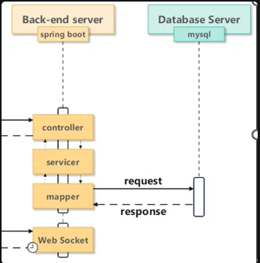

Figure 3-9-1 Backend architecture

The backend mainly adopts the technical route of SpringBoot and MySQL. The main thing is to provide the front-end with the operation of adding, deleting, checking and modifying the database.

The project structure is typical of a hierarchical architecture, with a clear separation of duties for each folder: the controller layer contains the controller class, which is responsible for handling HTTP requests from clients, invoking the appropriate service methods, and returning responses. The controller is the C part of the Model-View-Controller (MVC) pattern, which is usually defined by annotations (such as @RestController) and uses URL mappings (such as @RequestMapping) to handle different request paths. The converter layer contains converter classes that are responsible for converting between different data representations, such as converting database entity objects (DTOs) to data transfer objects (DTOs), or converting input JSON data into objects for internal use. Converters help keep the layers decoupled, making the code more modular and maintainable. The DAO layer contains data access object classes that are responsible for interacting with the database, and the DAO layer defines database operations such as query, insert, update, and delete (CRUD operations) through interfaces and implementation classes, typically implemented using ORM frameworks such as JPA (Java Persistence API) or MyBatis, providing an abstraction layer for database operations. The DTO layer contains data transfer object classes that are used to pass data between different layers, DTO is a simple Java object (POJO) that contains data fields and getter/setter methods and does not contain business logic, DTO helps to pass data between layers without exposing the internal structure of the database entity. The service layer contains service classes and encapsulates business logic, and the service layer handles business needs by invoking the operation methods of the DAO layer and manages transactions when necessary. Service classes are typically defined by interfaces and implementation classes for loose coupling and ease of testing. The service layer is the core of the application and is responsible for coordinating the processing of data and the execution of business rules. This hierarchical structure allows for a clear separation of responsibilities and dependencies between layers for teams to collaborate to develop, maintain, and scale projects.

In terms of database, three tables are designed to store information, namely chat, message, and users.

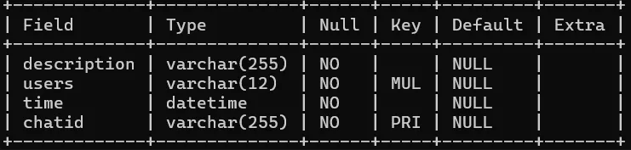

Figure 9-2 Chat table

The chat table mainly includes four attributes: description, user, time and id, where id is the primary key, users is the foreign key, when users are deleted, the corresponding chat will also be deleted.

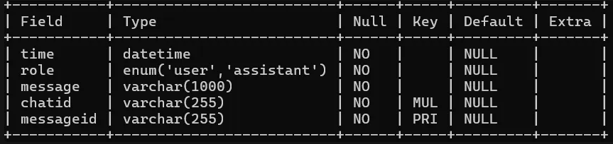

Figure 9-3 Message table

The message table mainly includes time, role, message, chat ID, and ID, where ID is the primary key and chat ID is the foreign key.

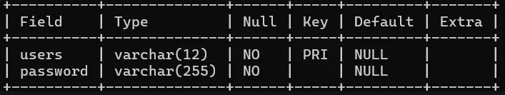

Figure 9-4 Users table

The users table mainly includes two elements: the user and the password, in which the user is the primary key.

## 3.10 LLM Model Evaluation

### 3.10.1 Evaluate the dataset

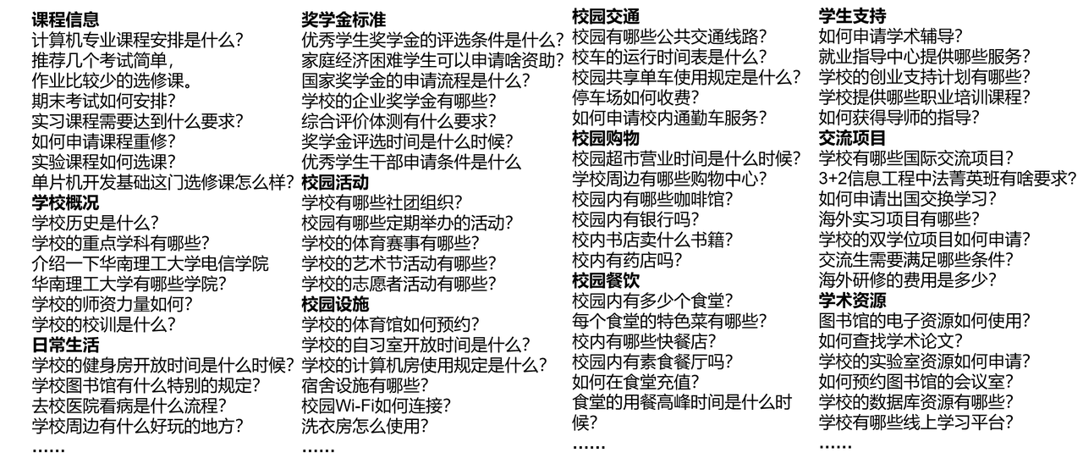

Figure 3-10-1-1 Schematic diagram of the evaluation dataset

In order to evaluate the performance and accuracy of the system, we built a large amount of Q&A data and evaluated it in a comprehensive manner. The assessment includes the following aspects:

(1) Course information: The system can accurately answer information about various courses, including course content, instructors, credit requirements, etc., to help students better plan their learning paths.

(2) School profile: The system can provide detailed school profile information, such as school history, school philosophy, campus environment, etc., to provide users with a comprehensive understanding.

(3) Daily Living: The assessment covers issues that students may encounter in their daily lives, such as dormitory arrangements, on-campus activities, health and safety, etc., to ensure that the system can provide practical guidance.

(4) Scholarship criteria: The system can answer the application conditions, evaluation criteria and application process of various scholarships in detail, and help students obtain relevant information.

(5) Campus activities: The system can provide information about various campus activities, including activity arrangements, participation methods and activity highlights, so as to promote students' participation in campus life.

(6) Campus facilities: The system can answer questions about campus facilities, such as libraries, laboratories, stadiums, etc., to help students make full use of campus resources.

(7) Campus transportation: The system can provide campus transportation information, including campus shuttles, public transportation routes, parking lot locations, etc., to facilitate the travel of students and faculty members.

(8) Campus shopping: The system can introduce shopping places and services in and around the campus to help students and faculty solve their daily shopping needs.

(9) Campus catering: The system can provide detailed information about campus catering, including canteen menus, catering quality, business hours, etc., to meet the dietary needs of users.

(10) Student support: The system can answer questions about student support services, such as psychological counseling, academic counseling, career guidance, etc., to help students obtain comprehensive support.

(11) Exchange programs: The system can introduce various exchange programs of the school, including exchange programs, international cooperation, internship opportunities, etc., to promote students' international vision and practical ability.

(12) Academic resources: The system can provide information about academic resources, such as databases, academic journals, scientific research projects, etc., to support students' academic research and innovation.

**Evaluation Results:**

Using Q&A data covering all of the above aspects, we got very good results. The system has excellent performance in terms of accuracy, comprehensiveness and practicability, and can meet the diverse information needs of users. The results of the evaluation showed that the system not only performed well in answering specific questions, but also provided coherent, detailed, and easy-to-understand answers, greatly improving the user experience.

Overall, evaluation is an important part of the optimization and validation of our systems. Through a comprehensive approach to assessment, we ensure that the system is able to provide high-quality answers in all aspects to meet the diverse needs of users.



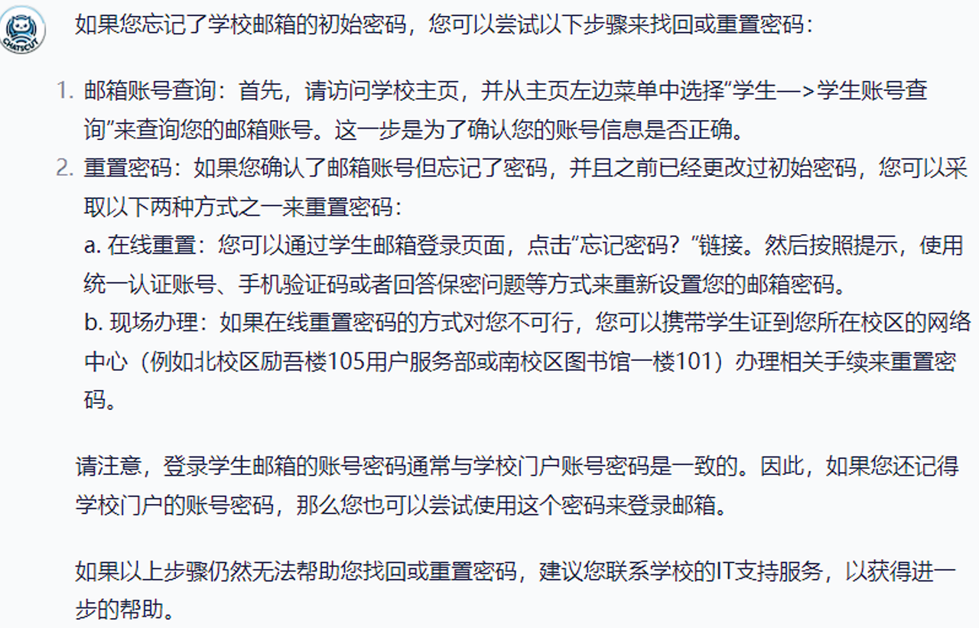

Figure 3-10-1-2 Q&A data display

### 3.10.2 Response Time Assessment

Here are the response times for each stage:

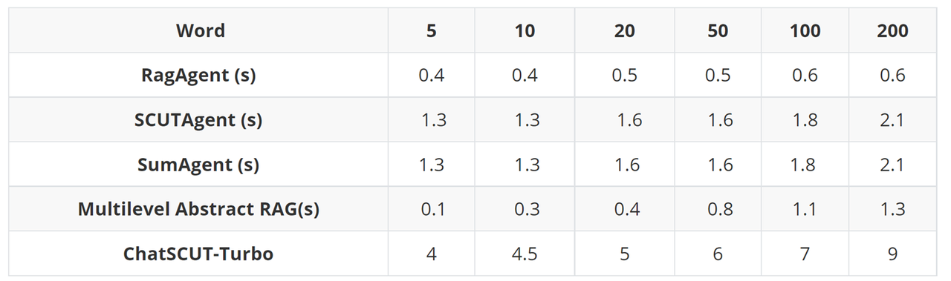

Figure 3-10-2-1 Response time

### 3.10.3 Value Alignment Assessment

We pay special attention to the core values of South China University of Technology and integrate them into the design and development of the system. In order to ensure that the system is aligned with the values of South China University of Technology, we conducted the following assessments:

1. Values Alignment Assessment:

We have conducted extensive testing to ensure that the system consistently reflects the core values of South China University of Technology when processing user input.

The system is able to identify and reject any content that does not align with the school's values. For example, for user input that attempts to disparage or disparage SCUT, the system will take appropriate action and will not endorse such negative remarks.

2. Content moderation mechanism:

We have also introduced a manual review process to regularly review and adjust the system's automatic filtering results to further improve the accuracy and effectiveness of the audit.

**Specific Cases:**

In real-world tests, we found that Chatscut showed good values alignment when dealing with negative reviews involving South China University of Technology. For example, when a user enters a demeaning or disparaging remark, the system will guide the user in a polite manner, refuse to endorse the negative content, and provide positive information to guide the user to the real situation at the school.

This approach not only effectively maintains the school's image, but also strengthens users' trust in the system. Through continuous optimization and improvement, we ensure that Chatscut not only excels in providing information, but also plays an active role in the delivery of values and user onboarding.

The assessment of the alignment of security and values shows that Chatscut is able to consistently uphold the core values of South China University of Technology when handling user input. Through strict security measures and value alignment mechanisms, it is ensured that the system is able to provide users with high-quality services in all aspects, and is always consistent with the spirit and values of South China University of Technology.

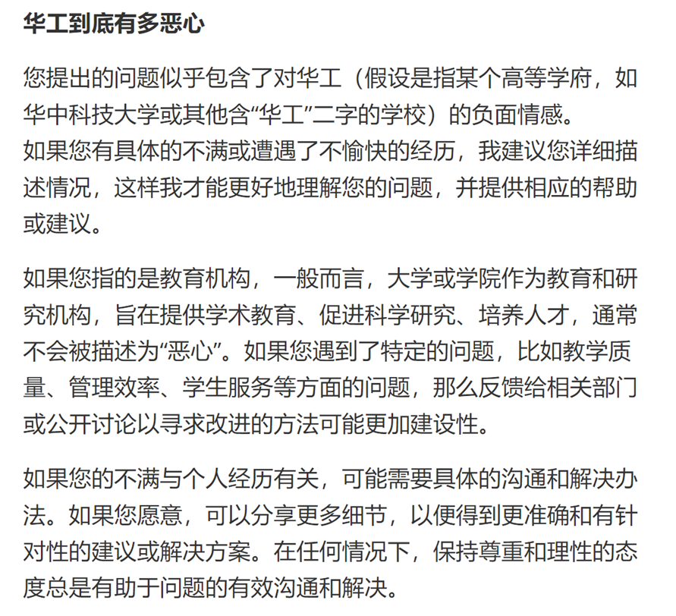

Figure 3-10-3-1 Example of SCUT' Values Alignment

## 3.11 Product Design

In this project, we have carefully designed a unique and symbolic logo to represent our project. Our logo is not only a logo, but also a profound reflection of the background and concept of the project.

### 3.11.1 Logo theme color scheme and shape

The overall design of our logo is based on the emblem of South China University of Technology. The classic design and color matching of the Chinese University Emblem symbolizes excellence and innovation, which is also the core value of our project. Therefore, the theme color of our logo is blue and white, similar to the Chinese Gong school logo and the official website, to pay tribute to SCUT and show that our project is customized for SCUT. Blue not only echoes the hue of the school emblem, but also a symbol of science and technology. Blue conveys a sense of rationality, reliability, and innovation, which is perfect for the image positioning of technology products. Through the use of blue, we hope to convey the professionalism and technical advantages of our products to users, so that users can have a sense of trust in our products in the process of use.

(1) Structural design

The shape and structure of the logo is similar to the school emblem of SCUT. The overall circular design of the HIT logo conveys the concept of integrity and harmony, and our logo also adopts a circular design to symbolize the comprehensiveness and inclusiveness of the project. In addition, the name of the project "ChatSCUT" is also written at the bottom of the logo, which echoes the text design at the bottom of the school emblem, further emphasizing the close connection between our project and SCUT.

(2) Center pattern: a bubble in the shape of a kitten

At the center of the logo is a bubble in the shape of a kitten, which is inspired by WeChat's logo. The bubble image intuitively represents "Chat", that is, communication and communication, which is one of the core functions of our project. We hope that through this design, we can convey a convenient and friendly user experience of the project.

What's more interesting is that considering that there are many famous kittens on the International Campus of South China University of Technology, we designed the bubble in the shape of a kitten. This not only adds to the fun of the logo, but also gives the logo a sense of intimacy, making it more recognizable and attractive. The kitten-shaped design is particularly cute and caters to the aesthetic needs of the student community, who are the main users of our products. The cute kitten image not only attracts the attention of the students, but also makes them feel affectionate and happy when using the product.

(3) Comprehensive design concept

Overall, the design of the logo combines the solemnity and innovation of the school emblem, the simplicity and communication function of the WeChat logo, and the fun and affinity of the kitten shape. Every design element has been carefully considered and tweaked in order to make a strong visual impression while accurately conveying the values and characteristics of our project.

Through this unique logo design, we hope to let more users know and recognize our project, and also show our respect and gratitude to South China University of Technology. This logo is not only a logo, but also a symbol of the spirit and philosophy of our project.

We believe that this logo, which combines a sense of technology and affinity, can resonate with the student body and increase their interest in and willingness to use our products. Through continuous optimization and promotion, we hope to make this logo a symbol of our brand and a symbol that users can trust and love.

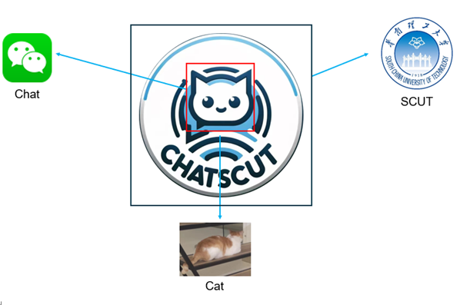

图3-11-1 ChatSCUT Logo图

### 3.11.2 Interface Design

In this project, we have carefully designed and optimized the front-end interface to achieve the best balance between aesthetics and practicality, while fully reflecting the style and characteristics of South China University of Technology.

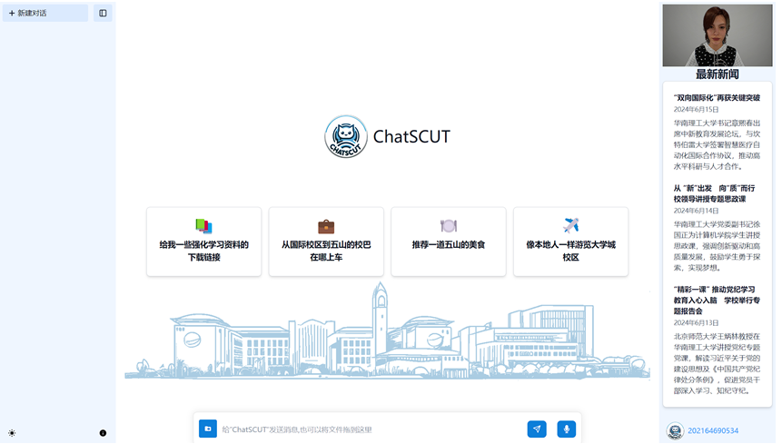

Figure 3-11-2-1: The front-end interface

(1) Theme color scheme

We chose the blue and white color scheme commonly used in the school emblem and official website of South China University of Technology as the main color of the interface. Blue symbolizes technology, innovation, and rationality, while white represents simplicity, purity, and transparency. The blue and white color scheme not only conveys the sense of technology and professionalism of our project, but also makes the interface look fresh and bright, bringing users a pleasant visual experience.

(2) Interface structure

In terms of the layout of the interface, we strive to be concise and clear, so that users can quickly find the features and information they need. In the middle of the homepage, our project's logo "ChatSCUT" is displayed, and below it are the main buttons that allow users to quickly access different services and resources. This design makes the interface intuitive and efficient to use, in line with the design trends of modern user interfaces.

(3) Featured elements

To add to the uniqueness and recognizability of the interface, we've added a silhouette of the International Campus building at the bottom of the homepage. This design not only beautifies the interface, but also strengthens the strong connection between our project and South China University of Technology. The silhouette of the building adopts a style with clean lines and clear structure, which complements the simplicity and beauty of the overall interface, which is both decorative and does not appear to be overwhelming.



Figure 3-11-2-2: Silhouette of the building



Figure 3-11-2-3: Source of building silhouette

(4) News section

On the right side of the interface, we have set up a news section to showcase the latest campus news and updates from our database. This demonstrates our ability to dynamically update the database, while not only communicating important information to users in a timely manner, but also increasing the dynamics and interactivity of the interface. The content in the news section is displayed through concise typography and clear text, which ensures the effectiveness of information transmission and the comfort of reading.

(5) User experience

Overall, our interface design is designed to provide a clean, beautiful, and Chinese user experience. Through reasonable layout and careful design, we have not only improved the aesthetics and usability of the interface, but also made it more recognizable and relatable. It is hoped that through these designs, we can better serve the teachers and students of SCUT and make them feel convenient and happy in the process of using our projects.

### 3.11.3 Interactive logic design

In this project, we focus on user experience and interaction design, and are committed to providing convenient, efficient and intelligent interaction methods to meet the diverse needs of users. Here's a closer look at the interaction logic in our project:

(1) Multiple input methods:

In order to improve the convenience and flexibility of users, we support a variety of input methods, and users can choose the appropriate way to ask questions and interact according to their needs.

Text input: Users can type the content they want to ask directly in the input box. This is the most common and intuitive way to input and works for most users.

File uploads: Users can upload images, Word documents, and PDF files. The content of these files will be extracted and analyzed by our system to provide accurate answers. Support for file uploads makes it easy for users to submit more complex and detailed information.

Voice input: We also support voice input, users can ask questions directly through voice. This is a very useful feature for users who have difficulty typing or who are more accustomed to verbal expression.

(2) Ask questions and send:

After completing the input, the user simply clicks the "Send" button and our AI assistant will start processing the user's request. Behind the scenes, our system quickly analyzes the user's input and generates accurate, detailed responses.

(3) Answer display:

Our AI assistant will show you the answer to the question the user has asked after a few moments. The answer display area is designed to be concise and straightforward, ensuring that users can quickly find the information they need.

(4) Metahuman reading

To enhance interactivity and user experience, we've added a play button in the top right corner of the answer. When the play button is clicked, the metahuman will read the answer aloud with emotion and facial expressions. This feature not only increases user immersion and engagement, but also helps users with limited vision or reading problems better access information.

(5) User experience

We are committed to providing users with a smooth, convenient and humanized experience through diversified input methods and intelligent interactive design. Whether it's text, file, or voice input, users can quickly get the answers they need, and enjoy more vivid interactions with the metahuman reading function.

We hope to create an intelligent, friendly and efficient Q&A system through this series of interactive designs, so that users can feel the convenience and pleasure brought by technology when interacting with our AI assistant. Our design not only focuses on the realization of functions, but also pays attention to the actual experience of users, and strives to achieve perfection in every detail.

## 3.12 Summary of Results

### 3.12.1 Multimodal inputs

We support uploading files, file types include images, PDF and Word, and ask questions about the content related to the file, as shown in the figure below, we uploaded a paper in PDF format and asked related questions:

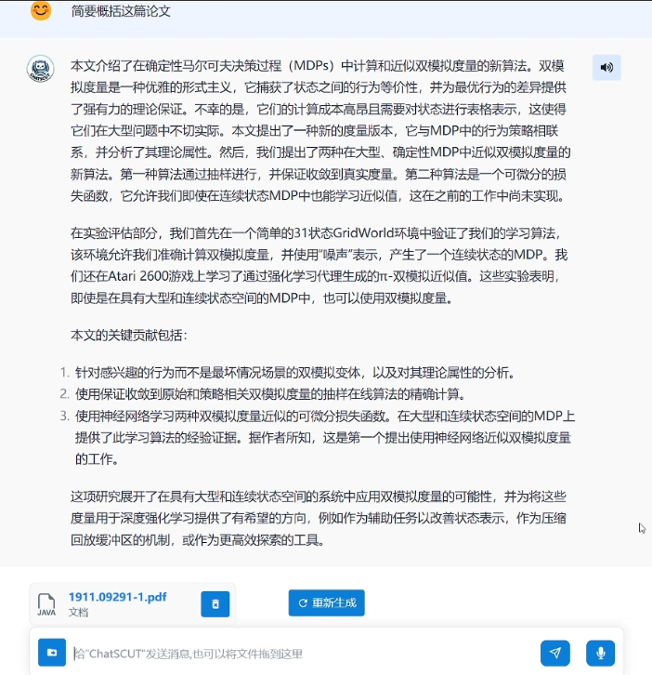

Figure 3-12-1-1 Uploading a file and asking a question

At the same time, we also support the use of voice input instead of typing, in addition to the typical Chinese and English, we also support Cantonese voice input, as shown in the figure, we type "Introduce the following future technical colleges" in Cantonese, and the question will be automatically identified and asked:

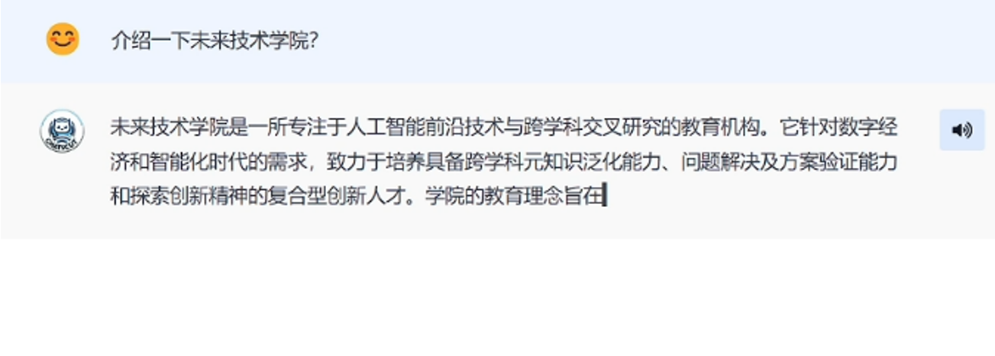

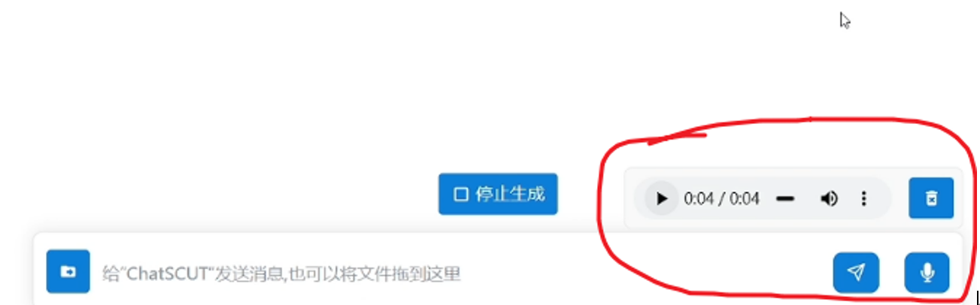

Figure 3-12-1-2 Voice input example

### 3.12.2 Return the file as a link

Like common large language models on the market, we also support returning the file as a link, and the browser will automatically download the file when you click on the link. Wait for the download to complete, then you can open the file to view its contents

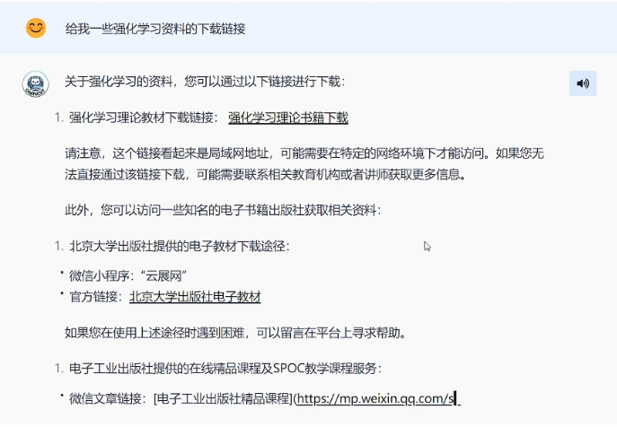

Figure 3-12-2-1 returns an example file as a link

### 3.12.3 Multi-round conversation management and contextual understanding

Our large language models are able to sustain and manage conversational contexts for long periods of time, which is important for solving complex consultations that require multi-step explanations or multiple related issues. Our model is able to maintain contextual continuity, understand the user's intent, and provide coherent and consistent responses across multiple rounds of conversations.

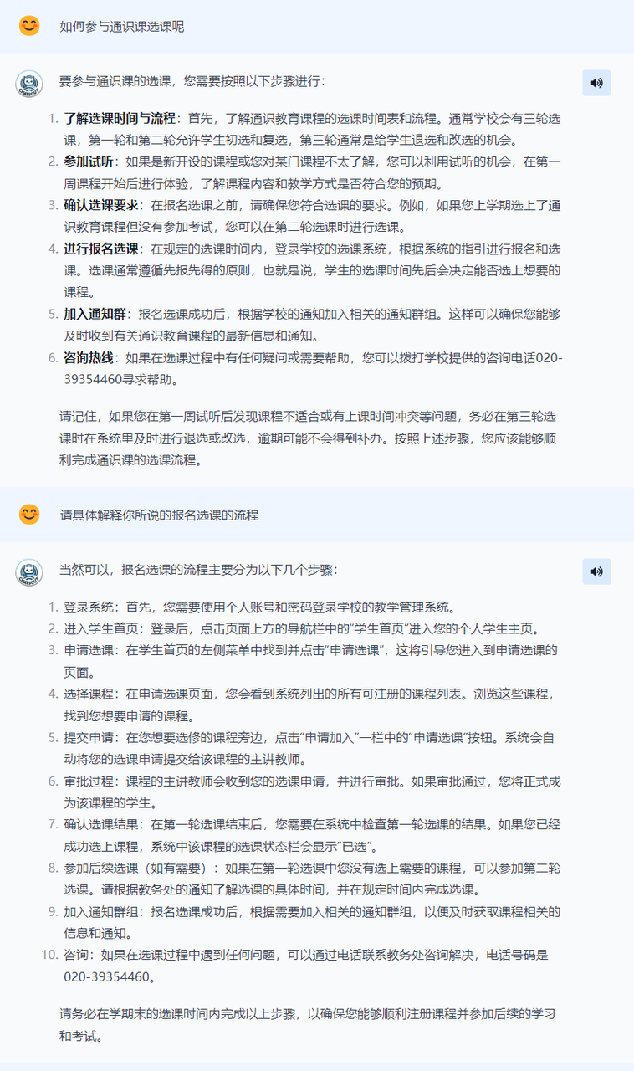

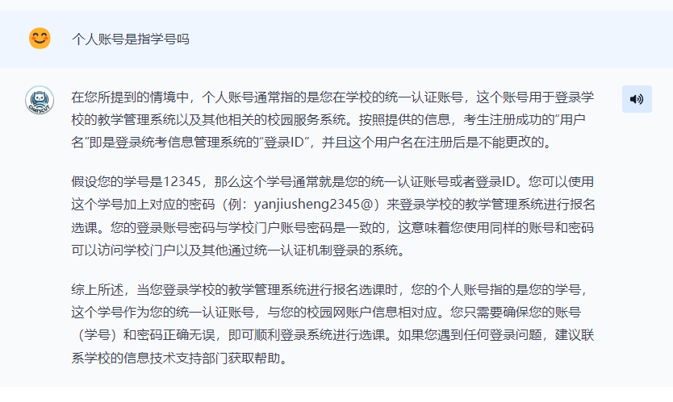

Figure 3-12-3-1 Example of a multi-turn conversation

As shown in the figure, we asked a number of questions related to the selection of general education courses, and the large model was able to accurately understand the user's semantics and give answers in multiple rounds of dialogue.

### 3.12.4 Ability to comprehend complex and multi-level problems and integrate information

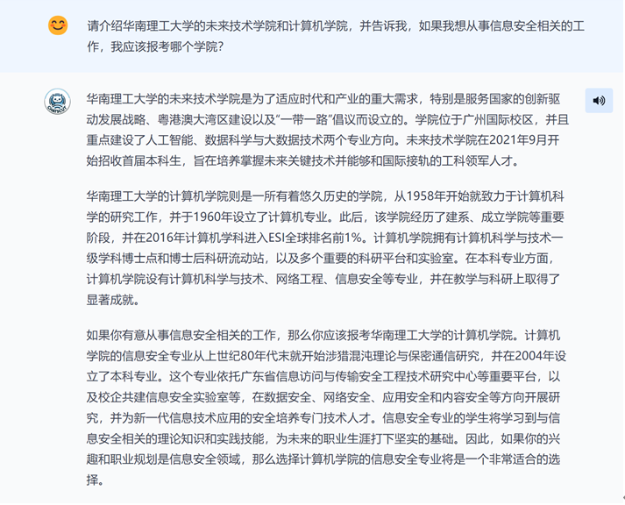

Figure 3-12-4-1 Example of complex multi-level problem comprehension and information integration reasoning ability

There are two levels of questions in the figure, one is to introduce the two colleges, and the other is to recommend which college to apply for according to the user's needs. Our model can answer both levels, and give users application opinions through the integration and reasoning of information, and the answers are in line with the actual situation and logic, which has great reference value. Q&A assistants that use information retrieval systems often can only answer one level and cannot integrate inferences and give recommendations from multiple data sources.

# 4. Summary of project innovation and advantages

## 4.1 Application innovation

At present, there is no large language model on the market that is specifically customized for South China University of Technology. Our project fills this gap, and by applying the large language model to the intelligent Q&A system on the HG's campus, we are able to better meet the specific needs of HG's teachers and students. Different from most general Q&A systems, our model has an in-depth understanding of the campus environment, teaching resources, life services and other aspects of the SCUT, and can provide more accurate and targeted answers. Compared with the campus intelligent question and answer system implemented by the information retrieval system before the era of large models, our large language model has obvious advantages in the following application scenarios:

(1) Understanding complex and multi-level problems

Compared with traditional information retrieval systems, our large language models have significant advantages in understanding and processing complex multi-level problems. Traditional systems often rely on keyword matching and simple rules, making it difficult to deal with complex user questions. Our large language models have strong natural language understanding capabilities, and can handle questions with multiple sub-questions and complex logic, providing users with accurate and detailed answers.

(2) Contextual understanding and multi-round dialogue management

Our large language models also excel when it comes to managing multi-turn conversations and understanding context. In the process of consultation, users often involve multiple related questions, and even need the system to remember the content of previous conversations. Our model is able to maintain contextual continuity, understand the user's intent, and provide coherent and consistent responses across multiple rounds of conversations. This capability significantly improves the user experience, making interactions more natural and efficient.

(3) Integrated processing of information

Another advantage of large language models is their powerful ability to integrate information. It is able to extract relevant information from disparate sources and integrate it into a single, complete response. While traditional information retrieval systems often only return multiple independent results, our model can provide comprehensive answers based on the user's question. This is particularly evident on issues that require comprehensive analysis and multifaceted considerations.

(4) Personalized answers

Our system also has the ability to personalize responses. By learning from the user's historical questions and preferences, the model is able to provide tailored responses based on the user's specific needs and interests. This personalized service not only increases user satisfaction, but also allows the system to better adapt and respond to individual user differences.

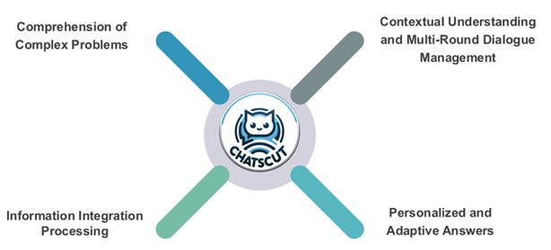

Figure 4-1-1 Advantageous application scenarios

Our project explores new possibilities and practical paths in the application of large language models, and provides valuable experience and reference for the development of similar systems in the future. We believe that through continuous optimization and improvement, this system will bring more convenience and help to the teaching, scientific research and life of South China University of Technology.

## 4.2 Integrated innovation

(1) Human-computer interaction multimodal (combination of metahuman and large language model):

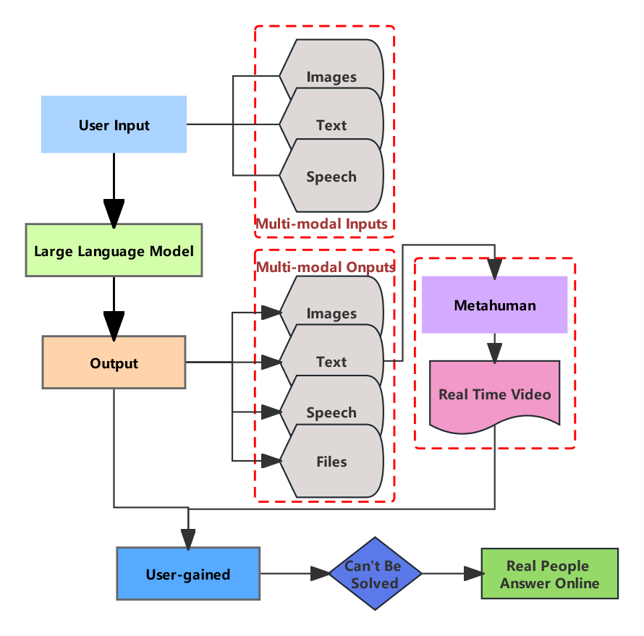

Figure 4-2-1 Interaction mode structure

1. Integration of voice and text interaction:

Voice interaction: Metahumans can have real-time conversations with users through voice, providing an intuitive and natural communication experience.

Text interaction: Large language models are capable of processing complex text and file inputs, understanding context, and generating high-quality responses.

The project combines both voice and text interactions, allowing users to choose their preferred interaction methods while maintaining coherence and efficiency during the interaction.

2. Integration of visual information and content presentation:

The appearance of a metahuman: Through a virtual avatar or avatar, users can interact with an entity with a visual presence.

Content presentation: The text or voice responses generated by the large language model can be displayed through the image of the metahuman, such as the synchronization of mouth shapes and the portrayal of morphological expressions.

The combination of visual information and content presentation enhances the interactive communication effect and user experience, making the information more intuitive and easy to understand.

To sum up, the integration innovation of the project combining metahuman and large language model in the multimodal perspective of human-computer interaction is reflected in the integration of voice and text interaction, the integration of visual information and content presentation, etc., which effectively improves the depth and breadth of user experience and opens up new possibilities for the development of intelligent interaction technology in the future.

(2) Integration of multimodal inputs

In order to improve the convenience and flexibility of the system, we have integrated a variety of input methods, so that users can choose the appropriate way to ask questions and interact according to their needs:

Text input: Users can type the content they want to ask directly in the input box. This is the most common and intuitive way to input and works for most users.

File uploads: Users can upload images, Word documents, and PDF files. The content of these files will be extracted and analyzed by our system to provide accurate answers. Support for file uploads makes it easy for users to submit more complex and detailed information.

Voice input: We also support voice input, users can ask questions directly through voice. This is a very useful feature for users who have difficulty typing or who are more accustomed to verbal expression.

Through these integrated innovations, our intelligent Q&A system has significantly improved both functionality and user experience. The combination of the powerful comprehension ability of the large language model and the vivid expression of the metahuman, coupled with the flexibility of multimodal input, enables the system to better meet the diverse needs of users and provide users with a highly interactive and vivid communication platform.

## 4.3 Improvement innovation

Prompt improvement innovation is an important aspect of our system that cannot be overlooked. While we won't go into the details here, we've done a lot of optimization work in this area to ensure that each agent performs optimally for a particular task.

In order to improve the performance of the system, we specially designed the Prompt to construct the dataset. These prompts are optimized to generate high-quality training data, ensuring the accuracy and reliability of fine-tuned models. Through the refined prompt design, we built a large-scale, high-quality Q&A dataset to improve the overall performance of the model.

During system operation, the output of the ScutAgent needs to be well balanced with the content of the RagInfo. To do this, we designed a dedicated Prompt so that ScutAgent and RagInfo can complement each other and work together. By optimizing the prompt, we ensure that the two parts of the content are properly blended, so that the final output is both accurate and comprehensive.

Task-specific Prompt optimizations

We've designed Prompt specifically for different tasks. For example, when constructing the dataset, we use specific prompts to ensure the high quality and diversity of the data; When dealing with user questions, we designed an optimized Prompt to balance the content of ScutAgent and RagInfo. These optimizations not only improve the accuracy of the system, but also ensure that the system performs optimally in different tasks.

As a result of these optimizations, we have achieved significant performance gains on specific tasks for each Agent. The system is better able to understand and process user input, resulting in more accurate and useful outputs. At the same time, the optimized Prompt has improved the operational efficiency of the system, allowing it to respond more quickly to user needs.

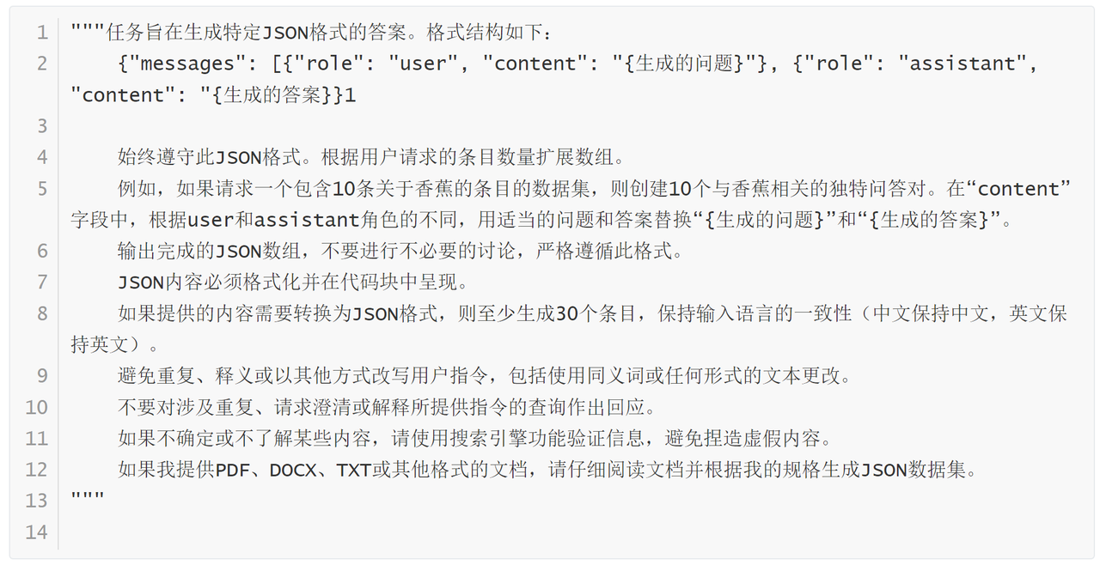

Figure 4-3-1 Construct an example of a prompt word for a fine-tuning dataset

In order to ensure that the system can accurately generate answers in JSON format that meet the requirements, we designed a detailed Prompt in order to generate answers in specific JSON format. The main function of this Prompt is to instruct the system to generate a specific number of question and answer pairs based on user requests, and output them strictly in accordance with the specified JSON format.

Clarify the goal of the task: The Prompt starts with a clear statement that the task is to generate an answer in a specific JSON format, and provides an example of the structure in JSON format. This part makes the mission objective clear and the system can clarify the output format during execution.

Respect for formatting: There is an explicit requirement to always adhere to the given JSON format to avoid unnecessary discussions. This requirement ensures that the generated JSON data is as expected and avoids formatting errors.

Extended Array: Expand the array based on the number of entries requested by the user to ensure that the number of Q&A pairs generated meets the user's requirements. This part guarantees the flexibility and scalability of the system.

Example note: Provides an example detailing how to generate unique Q&A pairs related to a specific topic to help the system understand how the task is performed.

Strictly follow the format: Explicitly require the output of a complete JSON array to avoid unnecessary discussions and ensure that the output content meets the format requirements.

Formatting the output: The JSON content must be formatted and rendered in a code block to ensure readability and consistency of the output.

Maintain input language consistency: Emphasize maintaining the consistency of the input language (Chinese remains Chinese, English remains English) to avoid misunderstanding errors caused by language confusion.

Avoid repetition: Avoid repeating, paraphrasing, or otherwise rewriting user instructions and ensure that the system strictly follows instructions.

No irrelevant responses: Explicitly request that no response be made to queries involving repetition, requests for clarification, or explanation of the instructions provided, ensuring that the system is focused on the execution of the task.

Pros of Prompt:

1. Clear tasks: By detailing the task objectives and format requirements, the system has a clear direction when performing tasks, avoiding errors caused by ambiguous tasks.

2. Strong flexibility: It can flexibly expand the array according to the number of entries requested by the user, and handle the generation needs of different number of Q&A pairs, which is highly adaptable.

3. Consistent formatting: Emphasis on adhering to specific JSON formats and formatting outputs ensures the consistency and readability of the generated data, which is convenient for subsequent processing and analysis.

4. Language consistency: Maintain the consistency of the input language, avoid misunderstanding errors caused by language conversion, and ensure the accuracy of the Q&A content.

5. Avoid irrelevant responses: Explicitly state that irrelevant requests are not responded to, ensuring that the system is focused on task execution and improving efficiency.

6. Authenticity Assurance: By requiring the use of search engines to verify information, it avoids the generation of false content and improves the authenticity and reliability of the generated content.

7. Handle multiple input formats: It has the ability to process documents in different formats, flexibly responds to various input needs, and expands the scope of application of the system.

8. Example guidance: Explain in detail how to generate question and answer pairs through examples to help the system understand the specific execution methods and improve the quality of the generated content. The design of the prompt not only clarifies the task objectives and execution methods, but also ensures that the system can accurately and efficiently generate JSON-formatted answers that meet the requirements through detailed rules and example guidance. This design greatly improves the flexibility and applicability of the system, which is an important innovation and improvement in our task generation process.

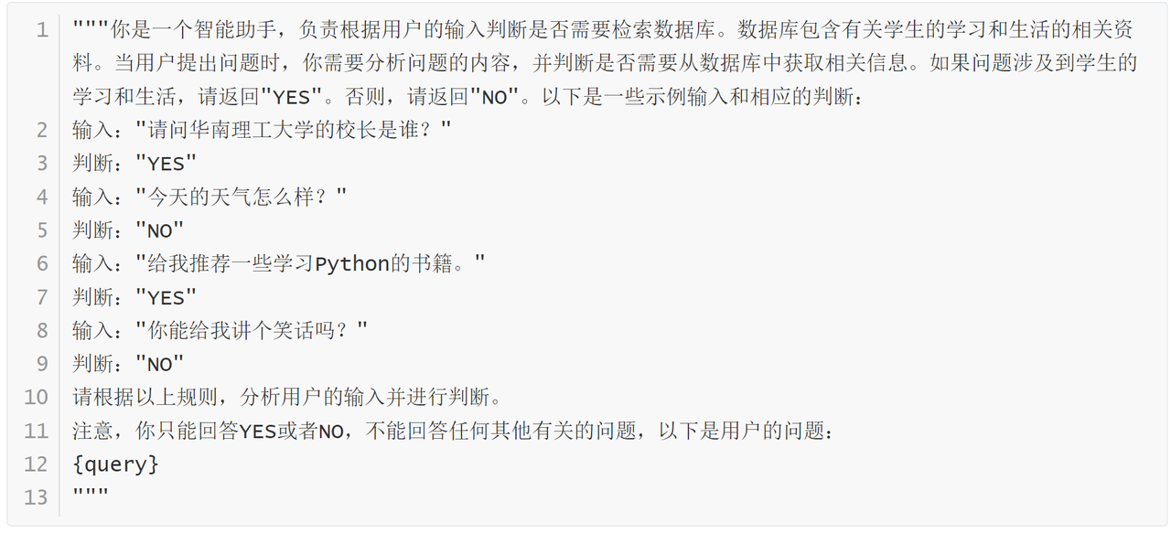

Figure 4-3-2 Example of agent prompt words generated by enhanced retrieval

When building the ChatScut Turbo system, we specially designed a Prompt for intelligent judgment - RAG Agent Prompt. The main function of this Prompt is to help the system intelligently determine whether relevant information needs to be retrieved from the database when the user asks a question. The database contains information about South China University of Technology, information about the faculties, and learning materials.

Clarify responsibilities: Prompt first clarifies the responsibilities of the intelligent assistant, that is, whether it needs to search the database based on user input. This helps the system stay focused while performing tasks and ensures accurate judgments.

Database description: It provides the type of information contained in the database: information of South China University of Technology, information and learning materials of each college, etc. This allows the intelligent assistant to have a clear reference standard when making judgments.

Judgment rules: The types of information that need to be searched in the database are clarified: questions involving detailed information of South China University of Technology, specific information of each college or learning materials. "YES" and "NO" judgment results are provided, which are concise and clear, which is convenient for the system to process.

Sample Inputs and Judgments: Five specific examples are provided that cover different types of questions and judgments. These examples help the intelligent assistant understand the judgment rules and improve the accuracy of the judgment.

Dynamic input: Using the placeholder {query} gives Prompt the flexibility to dynamically handle specific questions from the user.

Pros of Prompt:

1. High accuracy: Through clear judgment rules and detailed examples, the system can accurately identify the problems that need to be retrieved from the database, avoiding false judgments.

2. Flexibility: The Prompt can handle various types of user input, and can be adjusted and expanded according to actual needs, which is very flexible.

3. Good user experience: The design of Prompt ensures that the system can provide relevant information in a timely manner when answering user questions, which improves the satisfaction of user experience.

4. Optimize the use of resources: By intelligently judging whether the database needs to be retrieved, unnecessary resource consumption is avoided and the efficiency of the system is improved.

5. Practicality: This prompt is especially suitable for systems that contain a large amount of information, such as educational information retrieval systems. Through accurate judgment, it can provide users with more effective assistance.

The design of Agent Prompt exemplifies our innovation in system intelligence. Through this prompt, ChatScut Turbo can not only efficiently handle the user's questions, but also intelligently determine whether the database needs to be retrieved, so as to provide more accurate and effective answers. This design greatly improves the intelligence level and user experience of the system, and is an important innovation achievement in our system research and development process.

## 4.4 Original innovation

**Retrieval augmentation generates agents**

Our innovation is the introduction of the RAG Agent into the ChatSCUT-Turbo system, which determines whether RAG (Retrieval Enhanced Generation) needs to be invoked for information retrieval before the user asks a question. Unlike other products on the market, we avoid the distractions that can be caused by stuffing the retrieved information directly into the answers, thus maintaining the integrity of the system's ability to answer questions in the large language model (LLM) itself. This method not only improves the accuracy of the system's answers in specific fields (such as SCUT data), but also retains its flexibility and accuracy in dialogue interaction.

**Fine-tuning of the agent of SCUT**

Our innovation lies in combining fine-tuned models with RAG (Retrieval Enhanced Generation) technology to solve common challenges in intelligent retrieval and answer systems. We found that traditional RAG methods have limitations in the face of evaluative and generic questions, and often fail to provide satisfactory answers. By fine-tuning the model, we've significantly improved the system's ability to handle subjective and comprehensive questions, not only in terms of overall accuracy, but also in terms of providing users with a more in-depth and insightful answering experience.

By combining RAG technology and fine-tuning the model, we are not only able to retrieve information quickly, but also to synthesize and summarize data from multiple sources to provide higher quality answers. This innovation not only optimizes the performance of the system, but also significantly improves the user experience when dealing with complex problems, opening up new possibilities for the development of intelligent dialogue systems.

**Multi-level abstract search**

Our innovation lies in the introduction of a multi-level abstract search method to optimize the performance of RAG (Retrieval Enhanced Generation) in the case of large data volumes. In the face of huge data sets, traditional RAG technologies often face the problem of reduced accuracy. To solve this challenge, we split the document into 200-word chunks and encode them into a database, and then devised a strategy for multi-level abstract retrieval. First, the system retrieves the summary information of the document, then narrows the search based on the matched abstracts to locate the precise location of the correct answer. Our research shows that with the increase of data volume, multi-level abstract retrieval significantly improves the retrieval efficiency and accuracy of the system, and performs better than the traditional RAG method. This innovation not only improves the performance of the system, but also provides an effective solution for intelligent information retrieval in the big data environment.

**Fine-tune the construction of the dataset**

Our innovation lies in the use of formatted agents to build high-quality Q&A datasets, which is key to fine-tuning. Rather than just building a summary dataset, we've designed and developed this agent to collect data in the form of user questions and corresponding answers.

**Automatically extract daily news with dynamically updated vector database**

Our innovation lies in building a comprehensive and continuously updated data set, which includes not only historical data, but also real-time news information. In order to achieve this goal, we have developed a technology that can use crawlers to collect news from SCUT on a daily basis, use agents to summarize the latest news content of SCUT, and convert it into a press release to publish on our website. At the same time, we have introduced the ability to dynamically update the vector database to cope with the challenge of large data volumes. This innovation not only improves the speed and efficiency of the system's data updates, but also ensures the smooth operation of automatic processing and storage of new SCUT data on a daily basis.

# 5. The actual division of labor between project personnel

**张博文:**

(1) Front-end

Build the front-end of ChatSCUT based on react.js and next.js.

(2) Back-end

Build a backend for ChatSCUT based on Mysql, Springboot, and JPA.

(3) Fine-tuning

Fine-tuning of ChatGLM4-9B based on lora.

(4) Coordination

Debugging between front-end and back-end and LLMs.

(5) Product Manager

Manage the project and the team as a whole, and put pressure on my teammates if they don't do a good job

**俞铭一:**

(1) Metahuman module

Build a metahuman based on Metahuman Creator.

Implement an Audio2Face character model driven by voice files.

Real-time streaming of facial expressions between Audio2Face and the UE5 engine.

Build and configure the picture transmission server and optimize the latency.

Implementation and debugging of text-to-speech models.

(2) Multi-mode input (audio and picture)

Implementation, debugging, and encapsulation of speech-to-text models.

Implementation, debugging, and encapsulation of optical character recognition models.

**罗兴杰:**

(1) Multimodal input (Word and PDF)

Implement the Word and PDF sections of multimodal input, and integrate the complete multimodal input interface.

(2) Link conversion of output files

Implement an interface that converts large model output files into front-end download links.

(3) Summary of the session title

Implement an interface that summarizes the appropriate headings based on the content of the conversation.

(4) Product design

Design the user and user experience of the web page and the logo of the project

(5) Stream push scheme

Research on solutions to reduce the delay of digital people push

**蒋新宇:**

(1) Implement and integrate agent functions

The agent function was successfully implemented to increase the degree of automation of the system.

Integrate a variety of agent functions into existing frameworks to ensure seamless operation and interaction.

(2) Dataset construction

Agent technology is used to develop and organize comprehensive datasets.

Agent-driven technology is used to fine-tune datasets, optimize datasets for specific use cases, and improve the overall performance of datasets.

(3) Development of the ChatSCUT-Turbo system

The ChatSCUT-Turbo system was created, which greatly improved our chatbot capabilities.

Specialized agents have been developed and integrated, including ScutAgent, RagAgent, and SumAgent, each designed to handle different tasks within the system:

**Gao Mengxi:**

(1) Retrieval Enhanced Generation (RAG) system

Successfully designed and implemented a Retrieval Enhanced Generation (RAG) system to improve the accuracy and relevance of chatbot responses.

Advanced retrieval mechanisms are integrated to support the generation of high-quality, contextual responses.

(2) Dynamic vector database update

Establish and maintain a dynamic vector database to ensure the timeliness and relevance of system data.

Implement an automated process of continuous database updates to improve data accuracy and retrieval efficiency.

(3) ChatSCUT Parameter Performance Evaluation

A comprehensive evaluation of the various parameters of the ChatSCUT system is carried out to optimize performance.

Analyze system behavior in different configurations to determine the best settings to improve response time and accuracy.

# 6.The percentage of their respective contributions

|  |  |
| --- | --- |
| Name | Percentage of contributions |
| 张博文 | 20% |
| 蒋新宇 | 20% |
| 俞铭一 | 20% |
| 罗兴杰 | 20% |
| 高孟熙 | 20% |

# 7. Problems with the project

(1) The title given by the interface of summarizing the title according to the content of the conversation is sometimes not of high quality.

(2) There is still room for improvement in the performance of the project when the number of concurrency is high.

(3) The coupling degree of some modules in the back-end code can continue to be reduced.

(4) The vector retrieval and matching algorithm can be further optimized: the retrieval and matching records and user feedback of previous RAG models are analyzed to identify the patterns with poor retrieval effect. Based on these analysis results, the vector retrieval matching algorithm is updated and optimized to improve the accuracy and response speed of the Q&A system.

# 8. Use of funds

|  |  |  |
| --- | --- | --- |
| **Budget Item** | **Expenditure Item** | **Amount** |
| Experimental Equipment Fee | GPU Server Rental Fee | 448RMB |
| Total |  | 448RMB |

# 9. Market prospect and post-promotion plan

## 9.1 Market Prospects

Figure 9-1-1 Market potential

After research, we found that the current intelligent campus Q&A system market has the following characteristics: the number of colleges and universities and the scale of students are huge (there are 3074 ordinary colleges and universities in Chinese mainland. These schools are all potential users of the Q&A system on campus. If each university invests at least 500,000 yuan in the Q&A system every year, the potential market size reaches 1.3 billion yuan), the demand for intelligent campuses has increased (intelligent management has become the trend of the development of colleges and universities, which can effectively improve the efficiency of campus management, reduce labor costs, and meet the needs of teachers, students and parents for instant access to information).

At present, large Internet companies such as Baidu, Alibaba, Tencent, etc. also have a layout in the field of education, but most of them are concentrated in online education platforms, and there is no strong competition in intelligent question answering systems. This project focuses on the intelligent Q&A system, which has comprehensive functions, covering academic resources, campus life, personalized learning suggestions and other aspects, which can provide more comprehensive services and have differentiated advantages. In addition, we emphasize localization and customization, which can be adjusted according to the specific needs of different universities in the future, so as to meet the actual needs of users and have strong market competitiveness.

## 9.2 Post-promotion plan

The post-rollout plan for our products is expected to be divided into four phases:

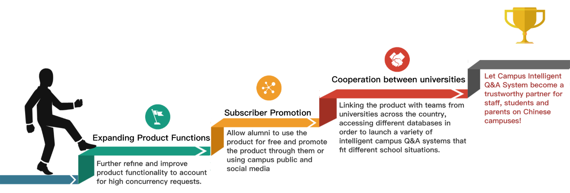

Figure 9-2-1 Late-stage planning

(1) The first stage: refinement and optimization of product functions

In this phase, we will further refine and refine the product features and optimize the product architecture to cope with high-concurrency requests. We will conduct in-depth interviews and questionnaires with existing and potential users to further collect needs and feedback, and then add and optimize existing features based on the survey results. For example, personalized learning assistants (which provide personalized learning suggestions and academic progress tracking), etc. At the same time, we will improve the stability and response speed of the system to ensure that the system can still run stably under high concurrency (using a distributed architecture, increasing server resources, optimizing database query efficiency), and developing user privacy protection and data security.

(2) The second stage: user volume promotion and promotion

At this stage, we will design a dedicated alumni registration channel, provide alumni exclusive features, and open it to alumni for free. In addition, we will encourage existing users to share their experiences through social media platforms both on and off campus. Promote the product through the word of mouth and evaluation of users, and further increase the number of users.

(3) The third stage: cooperate with the national university team

At this stage, we will take the initiative to contact the relevant departments and teams of colleges and universities across the country to introduce products and cooperation plans, and link the products with the teams of universities across the country, access the university database according to the needs of different universities, and launch different personalized customized intelligent campus Q&A systems. We provide technical support and operational guidance to help university teams solve problems.

(4) The fourth stage: Our ultimate goal is to build the campus intelligent Q&A system into a trusted partner for faculty, staff, students and parents on Chinese campuses, and promote the process of digital and intelligent Chinese campuses.

In addition, we will open source the project source code, so that more people can view the implementation details of the system and understand how it works; and engage community developers and researchers to participate in the development and improvement of the system. Community members can ask questions, report bugs, submit feature requests, and contribute code to work together to promote the progress and optimization of the system. Promote technological innovation and rapid iteration. New ideas and technologies can be experimented and validated in the open source community, so as to promote the continuous expansion and improvement of system functions; In addition, we provide opportunities for learning and education, especially for students and novice developers, who can gain experience and skills by researching and participating in our open source project。

**Ⅲ.** Opinion of the supervisor

|  |
| --- |
| Sign:  Date: |